 | MINISTRY OF EDUCATION AND TRAINING

FPT UNIVERSITY
Software Architecture Document
Pet Health Care System

Group 6
Group Members | Võ Trọng Luân - SE171436 - 15%  Trần Việt Phúc - SE171429 - 15%  Nguyễn Thanh Phong - SE171371 - 20%  Nguyễn Đặng Phương Nam - SE17142 - 15%  Bùi Duy Anh - SE171507 - 15%  Trần Đình Minh Quang - SE171391 - 20%
Supervisor | Mr. Nguyễn Ngọc Lâm
Ext Supervisor
Capstone Project code | SWD392

- Ho Chi Minh, 07/2024 -
Table of Contents

Acknowledgement 5
Definition and Acronyms 5
I. Project Introduction 6
1. Overview 6
1.1 Project Information 6
1.2 Project Team 6
2. Product Background 6
3. Existing Systems 7
3.1 TeleVet (https://www.tele-vet.ca/) 7
3.2 Vetster 7
3.3 Animal Healthcare (https://animalhealthcare.com/) 10
3.4 Thrive Pet Healthcare (https://www.thrivepetcare.com/) 11
4. Business Opportunity 12
5. Software Product Vision 12
6. Project Scope & Limitations 12
6.1 Major Features 12
6.2 Limitations & Exclusions 13
II. Software Requirement Specification 14
1. Product Overview 14
2. User Requirements 14
2.1 Actors 14
2.2 Use Cases 16
2.2.1 Diagram 16
2.2.2 Use Case List with Description 16
UC-01: Login (Authen User) 16
UC-02: Sign up (Guest) 18
UC-03: View services (Guest, Customer) 20
UC-04: View feedback (Guest, customer) 21
UC-05: View pet medical records (Customer) 22
UC-06: View pets being hospitalised healing process 24
UC-07: Feedback (Customer) 25
UC-08: Book an appointment (Customer) 27
UC-09: Logout (Authen User) 29
UC-10: Add service (Staff) 31
UC-11: Update service (Staff) 32
UC-12: Delete service (Staff) 34
UC-13: Modify price of a service (Staff) 36
UC-14: Add cage (Staff) 38
UC-15: Update cage (Staff) 40
UC-16: Delete room (Staff) 41
UC-17: View room and assign vet (Staff) 43
UC-18: View appointment list (Staff) 45
UC-19: Process cancel appointment (Staff) 47
UC-20: Make an appointment for offline customer (Staff) 48
UC-21: Assign vet for a room (Staff) 50
UC-22: View appointment schedule (Vet) 51
UC-23: Add medical record (Vet) 53
UC-24: Add medical record for pet in room (Vet) 55
UC-25: View revenue reports (Admin) 57
UC-26: Management System Configurations (Admin) 58
UC-27: Create an account (Admin) 59
UC-28: View account list (Admin) 60
3. Functional Requirements 61
3.1 System Functional Overview 61
3.1.1 Functional Requirements 61
3.1.2 Screen Authorization 61
3.2 Entity Relationship Diagram 62
4. Non-Functional Requirements 63
4.1 External Interfaces : 63
4.2 Quality Attributes 63
4.2.1 Usability: 63
4.2.2 Reliability: 63
4.2.3 Performance: 64
4.2.4 Design Constraints: 64
4.2.1 Security: 64
5. Requirement Appendix 64
5.1 Business Rules 64
5.2 Application Messages List 67
III. Software Design Description 68
1. System Design 68
1.1 System Architecture 68
2. Database Design 69
3. Detailed Design 80
3.1 Pet Feature 80
3.1.1 Activity Diagram 80
3.1.1.1 View Pet Activity Diagram 80
3.1.1.2 Create Pet Activity Diagram 81
3.1.1.3 Edit Pet Activity Diagram 82
3.1.1.4 Delete Pet Activity Diagram 83
3.1.2 Create Pet Sequence Diagram 84
3.2 Booking Feature 85
3.2.1 Activity Diagram 85
3.2.1.1 Book Appointment Activity Diagram 85
3.2.1.2 Cancel Appointment Activity Diagram 86
3.2.2 Book Appointment Sequence Diagram 86
3.2.3 Appointment State Machine Diagram 87
3.3 Medical Record Feature 88
3.3.1 Activity Diagram 88
3.3.1.1 Vet write 88
3.3.1.2 Customer View 89
3.3.2 Customer View Medical Record Sequence Diagram 90
3.4 Hospitalisation Feature 90
3.4.1 Activity Diagram 90
3.4.2 Sequence Diagram 90
3.5 Other Activity Diagrams 91
3.5.1 Register Activity Diagram: 91
3.5.2 Login Activity Diagram: 92

Acknowledgement
First, we would like to express our heartfelt gratitude to our supervisor, Mr. Nguyễn Ngọc Lâm, for his guidance throughout the entire project. His suggestions and recommendations have significantly improved the overall quality of the project.

We acknowledge that due to our lack of experience and unfamiliarity with certain technologies used in the project, mistakes were inevitable. We hope that people will overlook and forgive any errors or shortcomings. Thank you for your unwavering support. Regards

Definition and Acronyms
Acronym | Definition
BR | Business Rule
ERD | Entity Relationship Diagram
GUI | Graphical User Interface
SDD | Software Design Description
SRS | Software Requirement Specification
UC | Use Case

I. Project Introduction

1. Overview

1.1 Project Information
- Project name: Pet Health Care System
- Project code: SWD392
- Group name: Group 6
- Software type: Web Application

1.2 Project Team
Full Name | Role | Email | Phone
Võ Trọng Luân | Leader | luanvtse171436@fpt.edu.vn | 0971781359
Nguyễn Thanh Phong | Member | phongntse171371@fpt.edu.vn | 0938555758
Trần Việt Phúc | Member | phuctvse171429@fpt.edu.vn | 0944595483
Nguyễn Đặng Phương Nam | Member | namndpse171442@fpt.edu.vn | 0906657671
Trần Đình Minh Quang | Member | quangtdmse171391@fpt.edu.vn | 0901472180
Bùi Duy Anh | Member | anhbdse171507@fpt.edu.vn | 0901650980

2. Product Background
The pet care industry is witnessing a transformation driven by increased pet ownership rates and changing consumer expectations. Traditional pet care facilities often rely on outdated processes and software, leading to inefficiencies and customer dissatisfaction. Pet owners now demand personalised, convenient, and transparent care experiences for their beloved pets.

Managing a pet care facility involves intricate workflows with multiple stakeholders, including pet owners, veterinarians, support staff, and administrators. Coordinating these interactions effectively while maintaining high standards of care presents a significant challenge.

The COVID-19 pandemic has further emphasised the need for digital solutions in pet care, with remote access to services becoming essential. Online platforms for scheduling appointments, accessing telemedicine services, and monitoring pets' health remotely have gained traction.

In response, the development of a Pet Care Management System aims to streamline operations, improve communication, and enhance the overall quality of care provided to pets. By leveraging modern technology, this system addresses long standing pain points and aligns with the evolving needs of pet owners and veterinarians.

3. Existing Systems

3.1 TeleVet (https://www.tele-vet.ca/)
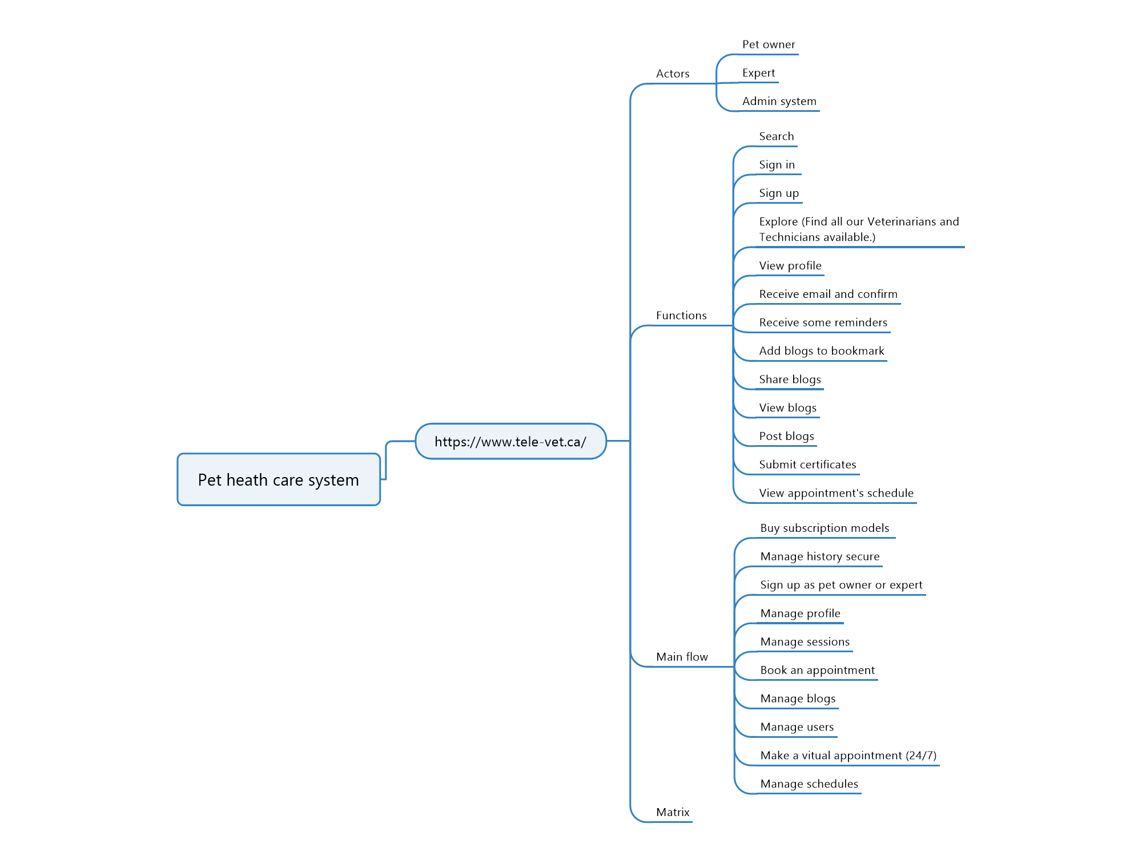
Matrix Function Link
Some of potential pros of the system:
- Increased accessibility to veterinary services for pet owners, especially those who live in remote locations or have difficulty travelling
- Improved communication between pet owners and veterinary professionals
- Ability for pet owners to manage their pet's medical history electronically
Some of the potential cons of the system include:
- Reliance on technology, which could pose a barrier for pet owners who are not comfortable using computers or smartphones
- Potential for privacy concerns about pet medical data
- Lack of in-person interaction between pet owners and veterinary professionals, which could be important for some pets

3.2 Vetster

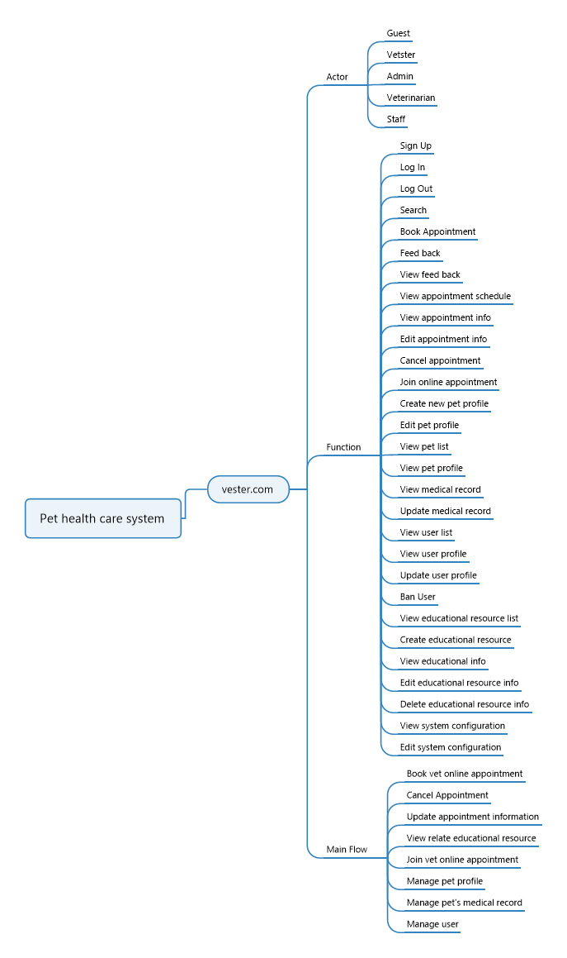
Matrix Function Link
Some of potential pros of the system:
- Convenience: Vetster offers the ease of consulting with a vet from home, saving time and hassle.
- Access: Especially beneficial for those in remote areas or with limited local veterinary services, providing access to professional advice and care.
- Cost-effective: Virtual appointments often come with lower overheads, potentially reducing costs compared to in-person visits.
- Flexible scheduling: Vetster allows for appointments at times convenient for pet owners, including evenings and weekends.
- Specialist consultations: Access to a network of licensed veterinarians with various specialties provides expert advice tailored to specific pet health needs.

Some of the potential cons of the system include:
- Limited physical examination: Virtual consultations may not allow for hands-on assessments, potentially limiting diagnostic accuracy.
- Technology requirements: Reliable internet and compatible devices are necessary, which might pose challenges for some users.
- Lack of in-person interaction: Some pet owners may miss the personal connection and trust-building of traditional veterinary visits.
- Legal and regulatory concerns: Compliance with local laws and regulations regarding virtual veterinary services may vary.
- Emergency situations: Virtual consultations are not suitable for emergencies, requiring a plan for immediate in-person care when needed

3.3 Animal Healthcare (https://animalhealthcare.com/)
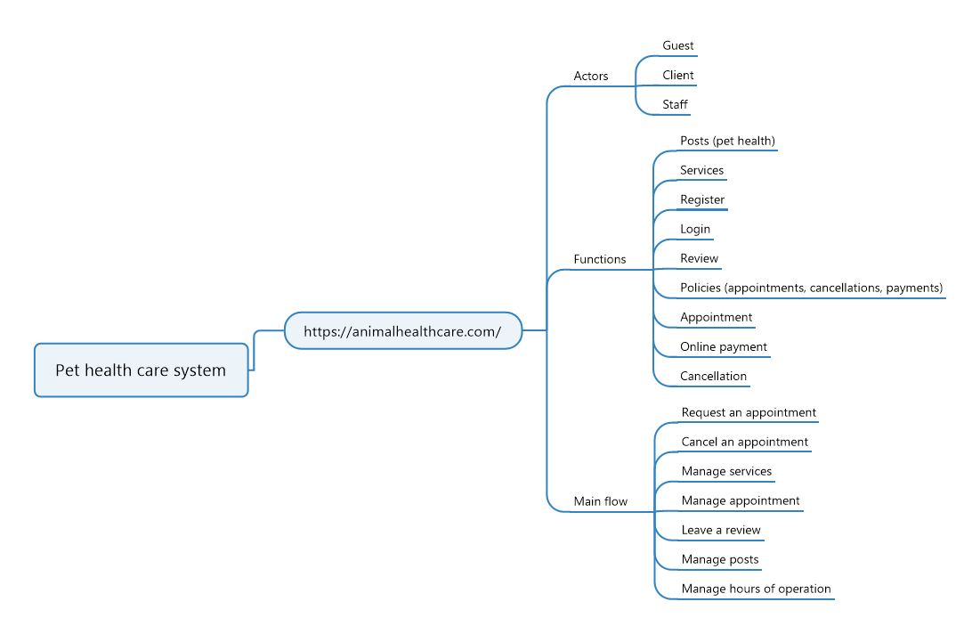

Matrix Function Link
Some of potential pros of the system:
- User-Friendly Interface: Easily browse services and policies, helping pet owners access necessary information smoothly.
- Online Payment System: Secure and simple payments can be made from home, streamlining the management of pet healthcare expenses.
- Flexible Appointment Scheduling: Offers appointment times that cater to even the busiest schedules, ensuring pets receive timely care.
- Easy Cancellation Options: Provides straightforward processes for rescheduling or cancelling appointments, accommodating unforeseen changes without major penalties.
Some of the potential cons of the system include:
- No Save for Later Option: Lacks the ability to save service choices or treatments for future consideration, which could inconvenience pet owners comparing options.
- No Appointment or Order History: Missing functionality to view past appointments or orders, making it difficult to track a pet’s healthcare history or maintain continuity of care.

3.4 Thrive Pet Healthcare (https://www.thrivepetcare.com/)
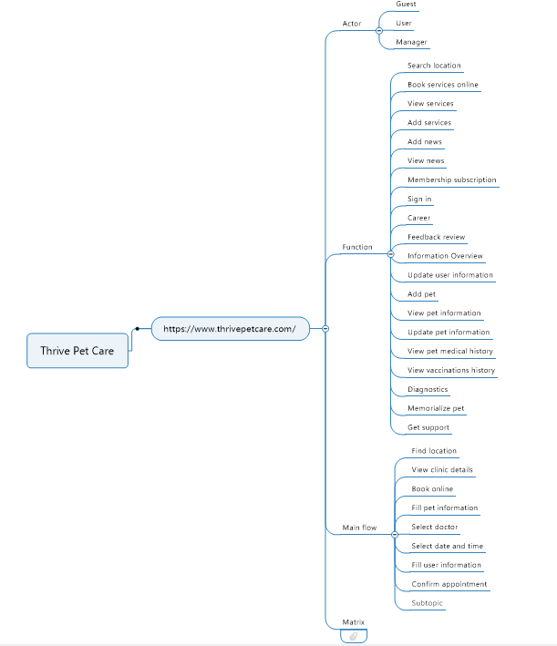
Matrix function link
Some of potential pros of the system:
- User-friendly interface: Easily for users to reach veterinary services and find the nearby location in order to quickly take care of their pet.
- Easy pet management: Users will be able to add new pets to their pet list and can view their pets’ information such as vaccination status, medical status and diagnostics of them.
- Pet memorialise: Users can memorialise their pets if they pass away.
- Extra services for membership: Every user will be able to use all standard features. Those who pay for membership services will be able to use some extra features.
Some of the potential cons of the system include:
- No order history: User will not be able to view their order history as well as the services they have booked

4. Business Opportunity
The growing trend of pet ownership underscores the need for a streamlined Pet Health Care System. Existing solutions lack centralised platforms for managing pet health records and appointments efficiently. Our proposed system offers a comprehensive solution, integrating features like centralised health records, appointment scheduling, medication management, and telemedicine. By addressing these gaps, it enhances communication between pet owners and veterinarians, aligning with market trends toward digitalization and personalised healthcare. This system not only saves time and improves service quality but also contributes to better health outcomes for pets, making it a compelling solution in the evolving pet healthcare landscape.

5. Software Product Vision
For pet owners seeking streamlined, comprehensive care management, our Pet Health Management System is a web platform designed to organise pet records, facilitate appointment scheduling, and enable seamless communication between owners, veterinarians, and clinic staff. By centralising pet care information and services, our system empowers owners to proactively manage their pets' health needs, from routine check-ups to emergency care. With intuitive features like appointment booking, medical history tracking, and real-time updates on pet hospitalizations, our platform simplifies pet care coordination, saving time and ensuring pets receive timely, personalised attention. Welcome to a world where pet health management is convenient, accessible, and efficient.

6. Project Scope & Limitations
The Pet Health Care System aims to provide a comprehensive digital platform for managing pet health records, scheduling appointments, facilitating communication between pet owners and veterinarians, and tracking pet wellness. It includes features for customers to manage pet information, book appointments, and monitor treatment progress, as well as functionalities for employees to handle bookings, manage hospitalizations, and schedule veterinarians. Veterinarians can set appointment times, conduct examinations, and care for hospitalised pets, while admins oversee user accounts, system configurations, and revenue reporting.

6.1 Major Features
For Customers:
- FE-01: Create, view, modify and delete pet lists
- FE-02: Viewing detailed pet information including medical history and vaccination records
- FE-03: Booking appointments with specific veterinarians, with cancellation policies
- FE-04: Checking in pets for appointments and paying for additional services
- FE-05: Rating appointments
- FE-06: Monitoring the treatment process if pets are hospitalised
For Staff:
- FE-07: Create, view, modify, delete, and archive information about rooms in the system
- FE-08: Handling bookings and cancellations, including refund processes
- FE-09: Create, view, modify, delete, and archive information about pets hospitalised, including updates for customers to track online
- FE-10: Scheduling veterinarians for direct appointments or hospital care
For Veterinarians:
- FE-11: Setting available appointment times for customers to choose when booking
- FE-12: Examining pets and recording examination details
- FE-13: Caring for hospitalised pets and documenting their records
For Admins:
- FE-14: Create, view, ban user accounts
- FE-15: Create, view, modify and delete system configurations
- FE-16: Generating revenue reports on a monthly, weekly, and daily basis

6.2 Limitations & Exclusions
LI-1: The system only stores 6 pets per customer
LI-2: Limited by the availability of veterinarians' schedules and the number of appointments that can be booked within a certain timeframe
LI-3: Limited by payment processing capabilities
LI-4: Limited by the number of rooms available for management within the system.
LI-5: Limited by the accessibility of real-time updates from veterinary staff and the frequency of updates provided.

II. Software Requirement Specification

1. Product Overview
1.1. Product Perspective:
- The pet health care services platform is an independent web application designed to facilitate pet health management for pet owners and veterinarians.
1.2. Product Features:
- User registration and login
- Pet health record management
- Appointment scheduling
- Vaccination record management
- Pet management
- Rating and feedback
- Pet room management
- Booking management
- Account management
1.3. User Classes and Characteristics:
- Customers: Need to manage their pet list. Easy to access pet health records and appointment scheduling. Need to track their pets if their pets are hospitalised.
- Veterinarians: Require tools for managing patient records, upcoming appointments with customers.
- Staffs: Need access to pet cage management, appointment scheduling management. Can manage pets which are hospitalised and provide information to customers.
- Administrators: Need access to user management and system maintenance features.
1.4. Operating Environment:
- Compatible with Windows, macOS, and Linux operating systems.
- Supported browsers include Chrome, Firefox, Safari, and Edge.
- Requires an internet connection for access.

2. User Requirements

2.1 Actors
# | Actor | Description
1 | Administrator | The administrators are responsible for managing the system. Specifically, they can manage permissions, accounts, and revenue.
2 | Staff | The staff members are responsible for handling bookings and cancellations, managing room information, and updating pet hospitalisation records for customers to track online. They can also schedule veterinarians for appointments or hospital care.
3 | Customer | The customers are responsible for managing their pet lists, viewing detailed pet information, booking and managing appointments, checking in pets, paying for services, rating appointments, and monitoring the treatment process of hospitalised pets.
4 | Vet | The veterinarians are responsible for setting available appointment times, examining pets, recording examination details, caring for hospitalised pets, and documenting their records.
5 | Guest | Guests are potential customers who can visit the web pages without accessing full system functionalities.
6 | Authen User | Authenticated users are individuals who have successfully logged into the system. They have access to various functionalities based on their assigned roles (such as Administrator, Staff, Customer, or Vet)

2.2 Use Cases

2.2.1 Diagram
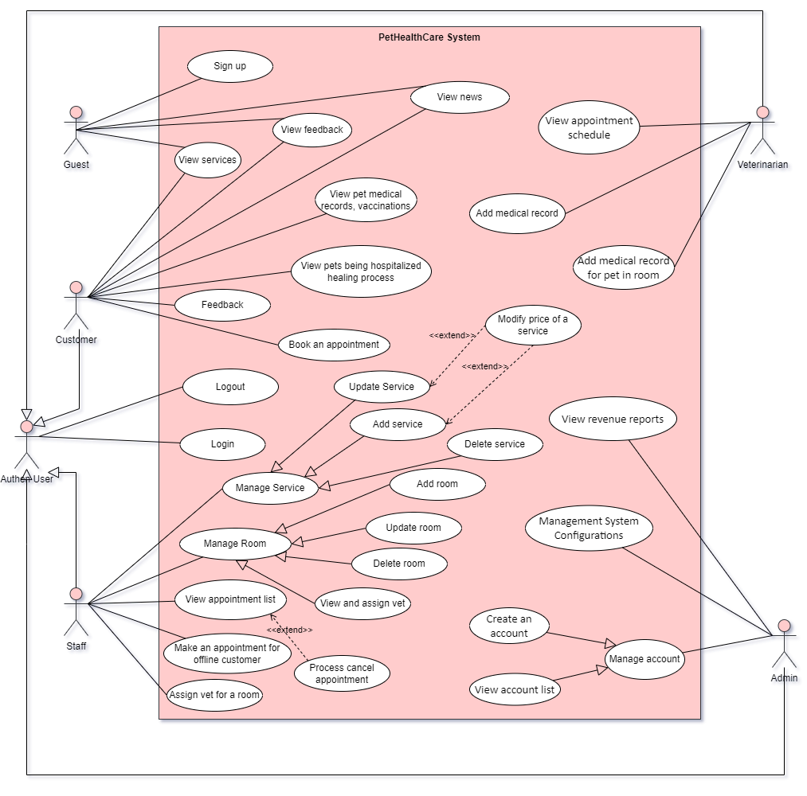

2.2.2 Use Case List with Description

UC-01: Login (Authen User)
Use Case Specification
Use Case No.: | UC-01
Use Case Name: | Login
Created By: | Nguyễn Thanh Phong
Date: | 22/05/2024 | Priority: | Must have
Actors: | Authen User
Summary: | Users login to system
Trigger: | For users who wants to use the system features
Preconditions: | The users needs to have a device which can connect to the wifi/mobile data
Postconditions: | - Users successfully log in to the system  - Users can use features in the system
Main Success Scenario/Main Flow/Normal Flow/Main Path:
Step. | Actor Action | System Response
1 | Users click on the [Login] button from the Header section | The system directs users to login page
2 | Users input username and password | The system waits for the users to finish inputting their login information
3 | Users press the [Login] button | The system validates users inputting information. System then authenticates the users and redirects them to the homepage

Alternative Flows: Forgot password
No. | Actor Action | System Response
2 | User input username and password | The system waits for the users to finish inputting their login information
3 | Users press the [Login] button | The system validates users inputting information. System then display the wrong password for the account
4 | Users follow the instruction to change his/her password | The system checks users’ inputting information and changes account passwords for customers. Then redirect them to login page
5 | Users input username and password | The system waits for the users to finish inputting their login information
6 | Users press the [Login] button | The system validates users inputting information. System then authenticates the users and redirects them to the homepage

Exceptions: System error
No. | Actor Action | System Response
2 | Users press the [Login] button | System encounters an error while validating credentials (e.g., server error). System then toasts an error message
3 | User decides to try again later or contacts support for assistance. | The system waits for customers next action

Business Rules: | BR-02

UC-02: Sign up (Guest)
Use Case Specification
Use Case No.: | UC-02
Use Case Name: | Sign up
Created By: | Nguyễn Thanh Phong
Date: | 22/05/2024 | Priority: | Must have
Actors: | Guest
Summary: | Guests register his/her account to the system
Trigger: | For guests who wants to use the system’s services
Preconditions: | The guest needs to have a device which can connect to the wifi/mobile data
Postconditions: | - The guest successfully creates his/her account in the system.  - Guest profile will be initialised due to successfully registering.
Main Success Scenario/Main Flow/Normal Flow/Main Path:
Step. | Actor Action | System Response
1 | Guests click on the [Register] button | The system directs guests to register page
2 | Guests input username, fullname, email, phone number, password and confirm password | The system waits for the guest to finish inputting their register information
3 | Guest press the [Register] button | The system checks guests inputting information and creates accounts for guests

Alternative Flows: Username Already Registered
No. | Actor Action | System Response
2 | Guests input username, fullname, email, phone number, password and confirm password | The system toast a notification inform guests that his/her username is already registered in the
3 | Guests input another username | The system waits for the guest to finish the inputting process
4 | Guest press the [Register] button | The system checks guests inputting information and creates accounts for guests

Exceptions: Network Timeout
No. | Actor Action | System Response
1 | Guests input username, fullname, email, phone number, password and confirm password | System validates the input but experiences a network timeout when trying to communicate with the server.
2 | Users try to reload the page again | The system will reload the page

Business Rules: | BR-01, BR-02

UC-03: View services (Guest, Customer)
Use Case Specification
Use Case No.: | UC-03
Use Case Name: | View services
Created By: | Nguyễn Thanh Phong
Date: | 22/05/2024 | Priority: | Must have
Actors: | Guest, Customer
Summary: | Guest, Customer can view detail of a service in system
Trigger: | For guest/customers who wants to know more about the system available services
Preconditions: | The guests/customers need to have a device which can connect to the wifi/mobile data
Postconditions: | - The guests/customers knows detail of each service in the system
Main Success Scenario/Main Flow/Normal Flow/Main Path:
Step. | Actor Action | System Response
1 | Guests/customers open the web application and are at the home page | The system shows guests/customers the home page layout of the system
2 | Guests/customers scroll down to the services section | The system shows guests/customers list of available services in the system
3 | Guests/customers click to a service to view its detail | The system shows guests/customers the detail of the service

Alternative Flows: Service details not available
No. | Actor Action | System Response
3 | Guests/customers click to a service to view its detail | System attempts to retrieve detailed information about the selected service but encounters an issue (e.g., data not found).
4 | User will return to services list | System shows guests/customers list of available services in the system
5 | Guests/customers click to another service to view its detail | System shows guests/customers detail of the service

Exceptions: System error
No. | Actor Action | System Response
3 | Guests/customers click to a service to view its detail | System encounters an error while trying to display the list of services (e.g., database connection failure). System then toasts the error message.
4 | Guests/customers decide to try again later and navigate back to home page | System directs guests/customers to home page

Business Rules:

UC-04: View feedback (Guest, customer)
Use Case Specification
Use Case No.: | UC-04
Use Case Name: | View feedback
Created By: | Nguyễn Thanh Phong
Date: | 22/05/2024 | Priority: | Must have
Actors: | Guest, Customer
Summary: | Guest, Customer can view some of the feedback of customers
Trigger: | For guest/customers who wants to know the quality of the system or the services
Preconditions: | The guests/customers need to have a device which can connect to the wifi/mobile data
Postconditions: | - The guests/customers knows more about the quality of the system or services
Main Success Scenario/Main Flow/Normal Flow/Main Path:
Step. | Actor Action | System Response
1 | Guests/customers open the web application and are at the home page | The system shows guests/customers the home page layout of the system
2 | Guests/customers scroll down to the feedback section | The system shows guests/customers some of feedbacks of other customers

Alternative Flows: Feedback list is not available
No. | Actor Action | System Response
2 | Guests/customers scroll down to the feedback section | System attempts to retrieve a feedback list but encounters an issue (e.g., data not found).
3 | Guests/customers decides to try again later | Systems wait for user actions

Exceptions: System error
No. | Actor Action | System Response
2 | Guests/customers scroll down to the feedback section | The system fetch the feedback data but get error from the server (e.g., internal server error)
3 | Guests/customers decides to try again later | Systems wait for user actions

Business Rules:

UC-05: View pet medical records (Customer)
Use Case Specification
Use Case No.: | UC-05
Use Case Name: | View pet medical records
Created By: | Nguyễn Thanh Phong
Date: | 22/05/2024 | Priority: | Must have
Actors: | Customer
Summary: | Customer can view some of the feedback of customers
Trigger: | Customer wants to track his/her pets medical records or vaccination records
Preconditions: | The customers need to have a device which can connect to the wifi/mobile data
Postconditions: | - The customers know his/her pet medical records or vaccination records
Main Success Scenario/Main Flow/Normal Flow/Main Path:
Step. | Actor Action | System Response
1 | Customers open the web application and are at the home page | The system customers the home page layout of the system
2 | Customers click on “Pet” section in Header section | The system directs customers to their “Pet Overview” page
3 | Customers choose one of their pets displayed on page or choose on the sidebar | The systems directs customers to the “Pet Detail” page

Alternative Flows: Feedback list is not available
No. | Actor Action | System Response
2 | Guests/customers scroll down to the feedback section | System attempts to retrieve a feedback list but encounters an issue (e.g., data not found).
3 | Guests/customers decides to try again later | Systems wait for user actions

Exceptions: System error
No. | Actor Action | System Response
2 | Guests/customers scroll down to the feedback section | The system fetch the feedback data but get error from the server (e.g., internal server error)
3 | Guests/customers decides to try again later | Systems wait for user actions

Business Rules: | BR-04, BR-06

UC-06: View pets being hospitalised healing process
Use Case Specification
Use Case No.: | UC-06
Use Case Name: | View pets being hospitalised healing process
Created By: | Võ Trọng Luân
Date: | 22/05/2024 | Priority: | Medium
Actors: | Customer
Summary: | Customers can view the healing process of their pets that are currently hospitalised.
Trigger: | Customers want to check the progress of their hospitalised pet's healing process.
Preconditions: | The customer must have a device connected to the internet (WiFi/mobile data).  The customer must have a registered account and logged into the system.
Post–conditions: | The customer knows the current status and healing progress of their hospitalised pet.
Main Success Scenario/Main Flow/Normal Flow/Main Path:
Step. | Actor Action | System Response
1 | Customer opens the web application and is at the home page. | The system displays the home page layout.
2 | Customer clicks on the "Pet" section in the Header section. | The system directs the customer to their "Pet Overview" page.
3 | Customer chooses one of their hospitalized pets displayed on the page or chooses from the sidebar. | The system directs the customer to the "Pet Detail" page.

Alternative Flows: N/A
Exceptions:
No. | Actor Action | System Response
1 | Customer chooses one of their hospitalized pets displayed on the page or chooses from the sidebar. | The system fetches the healing progress data but gets an error from the server (e.g., internal server error).
2 | Customer decides to try again later. | The system directs the customer to the "Pet Detail" page.

Business Rules: | BR-04, BR-05

UC-07: Feedback (Customer)
Use Case Specification
Use Case No.: | UC-07
Use Case Name: | Feedback
Created By: | Võ Trọng Luân
Date: | 22/05/2024 | Priority: | Medium
Actors: | Customer
Summary: | Customer can provide feedback regarding a specific appointment with the veterinarian.
Trigger: | Customer wants to give feedback on a specific appointment they had with the veterinarian.
Preconditions: | The customer must have a device connected to the internet (WiFi/mobile data).  The customer must have a registered account and logged into the system.  The customer must have had at least one appointment with the veterinarian.
Post–conditions: | The customer successfully submits their feedback.  The feedback is recorded in the system and associated with the relevant appointment for future reference.
Main Success Scenario/Main Flow/Normal Flow/Main Path:
Step. | Actor Action | System Response
1 | Customer opens the web application and is at the home page. | The system displays the home page layout.
2 | Customer clicks on the "Feedback" section in the Header section. | The system directs the customer to the "Feedback" page.
3 | Customer selects the specific appointment they want to give feedback on. | The system displays a list of past appointments for the customer to choose from.
4 | Customers fill in the feedback form with their comments and ratings about the appointment. | The system displays the feedback form.
5 | Customer submits the feedback form. | The system validates the form data and records the feedback.
6 | Customer receives a confirmation message. | The system displays a confirmation message indicating that the feedback has been successfully submitted.

Alternative Flows: N/A
Exceptions:
No. | Actor Action | System Response
1 | Customer submits the feedback form. | The system fetches the feedback data but gets an error from the server (e.g., internal server error).  System displays an error message indicating the issue.
2 | Customer decides to try again later. | The system displays the feedback form.

Business Rules: | BR-04, BR-06, BR-07

UC-08: Book an appointment (Customer)
Use Case Specification
Use Case No.: | UC-08
Use Case Name: | Book an appointment
Created By: | Võ Trọng Luân
Date: | 22/05/2024 | Priority: | High
Actors: | Customer
Summary: | Customers can book an appointment by choosing their pet first, then selecting the date, time, and veterinarian.
Trigger: | Customers want to book an appointment for their pet with a veterinarian.
Preconditions: | The customer must have a device connected to the internet (WiFi/mobile data).  The customer must have a registered account and logged into the system.  The customer must have at least one pet registered in the system.
Post–conditions: | The appointment is successfully booked and confirmed.  The customer receives a confirmation message with appointment details.
Main Success Scenario/Main Flow/Normal Flow/Main Path:
Step. | Actor Action | System Response
1 | Customer opens the web application and is at the home page. | The system displays the home page layout.
2 | Customer clicks on the "Appointments" section in the Header section. | The system directs the customer to the "Appointments" page.
3 | Customer clicks on the "Book Appointment" button. | The system displays the "Book Appointment" form.
4 | Customer selects the pet for the appointment. | The system displays the pet selection dropdown menu.
5 | Customer selects the date for the appointment. | The system displays the date picker.
6 | Customer selects the time for the appointment. | The system displays the time slots available for the selected date.
7 | Customer selects the veterinarian for the appointment. | The system displays a list of available veterinarians for the selected date and time.
8 | Customer confirms the appointment details and submits the form. | The system validates the form data and books the appointment.
9 | Customer receives a confirmation message with the appointment details. | The system displays a confirmation message indicating that the appointment has been successfully booked.

Alternative Flows: N/A

Exceptions:
No. | Actor Action | System Response
1 | Customer submits the appointment form. | The system fetches the appointment data but gets an error from the server (e.g., internal server error).  System displays an error message indicating the issue.
2 | Customer decides to try again later. | The system displays the "Book Appointment" form.

Business Rules: | BR-04, BR-08, BR-09

UC-09: Logout (Authen User)
Use Case Specification
Use Case No.: | UC-09
Use Case Name: | Logout
Created By: | Võ Trọng Luân
Date: | 22/05/2024 | Priority: | High
Actors: | Authen User
Summary: | An authenticated user can log out from the system.
Trigger: | The user wants to log out of the system.
Preconditions: | The user must be logged into the system.
Post–conditions: | The user is logged out and returned to the login page or home page.  The user’s session is terminated.
Main Success Scenario/Main Flow/Normal Flow/Main Path:
Step. | Actor Action | System Response
1 | User clicks on the "Logout" button or link. | The system logs the user out and terminates their session.
2 | User is redirected to the login page or home page. | The system displays the login page or home page.

Alternative Flows: N/A
Exceptions:
No. | Actor Action | System Response
1 | User clicks on the "Logout" button or link. | System encounters a server error and fails to log out the user.  System displays an error message indicating the issue.
2 | User decides to close the browser or try logging out later. | System waits for user actions.

Business Rules: | BR-04, BR-10, BR-11

UC-10: Add service (Staff)
Use Case Specification
Use Case No.: | UC-10
Use Case Name: | Add service
Created By: | Võ Trọng Luân
Date: | 22/05/2024 | Priority: | High
Actors: | Staff
Summary: | This use case describes the process for staff to create the detailed information of a service on the system.
Trigger: | The staff needs to add a service.
Preconditions: | Staff must log in and access the "Manage Services" function.  The staff account must have appropriate permissions to add services.
Post–conditions: | The service is added to the system database.
Main Success Scenario/Main Flow/Normal Flow/Main Path:
Step. | Actor Action | System Response
1 | Staff logs into the system. | The system displays the staff homepage.
2 | Staff selects “Manage Service” tab | The system displays a list of services.
3 | Staff clicks the "Add Service" button. | The system displays the "Add Service" form.
3 | Staff fills in the service details (e.g., service name, description, pricing, availability). | The system validates the input fields as staff fills them in.
4 | Staff submits the form. | The system displays a confirmation dialog box with a warning message about permanently deleting the service.
 | Staff confirms deletion | The system validates the form data and adds the service to the database.
4 | The system displays a success message indicating that the service has been successfully added. | The system updates the list of services to include the newly added service.

Alternative Flows: N/A
Exceptions:
No. | Actor Action | System Response
1 | Staff enters incorrect login credentials. | The system displays an error message and prompts the staff to re-enter their credentials. The system may also offer options to reset a forgotten password.
2 | System encounters an error during data saving. | The system displays an error message indicating the failure to save changes. Staff may need to try again later or contact system administrators for assistance.

Business Rules: | BR-04, BR-49, BR-50, BR-51

UC-11: Update service (Staff)
Use Case Specification
Use Case No.: | 11
Use Case Name: | Update service
Created By: | Trần Đình Minh Quang
Date: | 22/05/2024 | Priority: | High
Actors: | Staff
Summary: | This use case describes the process for staff to update the detail information of a service on the system
Trigger: | The staff needs to remove a service that is no longer offered.
Preconditions: | Staff have to log in and access the "Manage Services" function.  The staff account must have appropriate permissions to delete services.  The service to be deleted is not currently associated with any active subscriptions or bookings.
Post–conditions: | The service is permanently removed from the system database.  The service is no longer displayed in the list of services.
Main Success Scenario/Main Flow/Normal Flow/Main Path:
Step. | Actor Action | System Response
1 | Staff logs into the system | The system displays the staff homepage.
2 | Staff selects “Manage Service” tab | The system displays a list of services.
3 | Staff chooses a service in list | The system displays detail information of the service
3 | [Alternative 1] Staff search a service and choose it | The system finds and displays services that match the keyword. Staff can then choose a service from the search results.
4 | Staff clicks the "Delete" button | The system displays a confirmation dialog box with a warning message about permanently deleting the service.
 | Staff confirms deletion | * The system checks if the service has any active subscriptions or bookings. * If there are no active associations, the system permanently deletes the service from the database and displays a success notification. * If there are active associations, the system displays an error message explaining why deletion cannot be completed and provides options (e.g., cancel bookings, end subscriptions).
4 | [Alternative 1] Staff click “Cancel” | The system discards any unsaved changes and returns to the list of services.

Alternative Flows:
No. | Actor Action | System Response
1 | Staff search a service | The system displays a message indicating "No results found" if no services match the keyword.
2 | Staff clicks "Cancel" on the service detail page | The system hides the detail information page and returns to the list of services.

Exceptions:
No. | Actor Action | System Response
1 | Staff enters incorrect login credentials. | The system displays an error message and prompts the staff to re-enter their credentials. The system may also offer options to reset a forgotten password.
2 | System encounters an error during data saving. | The system displays an error message indicating the failure to save changes. Staff may need to try again later or contact system administrators for assistance.

Business Rules: | BR-04, BR-49, BR-50, BR-51

UC-12: Delete service (Staff)
Use Case Specification
Use Case No.: | 12
Use Case Name: | Delete service
Created By: | Trần Đình Minh Quang
Date: | 22/05/2024 | Priority: | High
Actors: | Staff
Summary: | This use case describes the process for staff to delete a service from the system.
Trigger: | The staff want to update a service
Preconditions: | Staff have to login and access manage services function  The staff account must have appropriate permissions to update service information.
Post–conditions: | The changes to the service information are saved in the system database.  The system reflects the updated information.
Main Success Scenario/Main Flow/Normal Flow/Main Path:
Step. | Actor Action | System Response
1 | Staff logs into the system | The system displays the staff homepage.
2 | Staff selects “Manage Service” tab | The system displays a list of services.
3 | Staff chooses a service in list | The system displays detail information of the service
3 | [Alternative 1] Staff search a service and choose it | The system finds and displays services that match the keyword. Staff can then choose a service from the search results.
4 | Staff clicks the "Delete" button | The system displays a confirmation dialog box with a warning message about permanently deleting the service.
5 | Staff confirms deletion | The system checks if the service has any active appointment is booking  If there are no active associations, the system changes the service’s available status into “false” in the database and displays a success notification.  If there are active associations, the system displays an error message explaining why deletion cannot be completed and provides options (e.g., cancel bookings).
5 | [Alternative 1] Staff click “Cancel” | The system closes the confirmation dialog and keeps the service information displayed.

Alternative Flows:
No. | Actor Action | System Response
1 | Staff search a service | The system displays a message indicating "No results found" if no services match the keyword.
2 | Staff clicks "Cancel" on the service detail page | The system hides the detail information page and returns to the list of services.

Exceptions:
No. | Actor Action | System Response
1 | Staff enters incorrect login credentials. | The system displays an error message and prompts the staff to re-enter their credentials. The system may also offer options to reset a forgotten password.
2 | System encounters an error during data deletion. | The system displays an error message indicating the failure to delete the service. Staff may need to try again later or contact system administrators for assistance.
3 | The service has active bookings. | The system displays an error message explaining that the service cannot be deleted due to active associations. The system may provide options to manage the associated bookings before deletion can occur.

Business Rules: | BR-04, BR-51, BR-52, BR-53

UC-13: Modify price of a service (Staff)
Use Case Specification
Use Case No.: | 13
Use Case Name: | Modify Price of a Service
Created By: | Trần Đình Minh Quang
Date: | 22/05/2024 | Priority: | High
Actors: | Staff
Summary: | This use case describes the process for staff to update the price of a service.
Trigger: | The staff needs to adjust the price of a service due to changes in costs, promotions, or other reasons.
Preconditions: | Staff have to log in and access the "Manage Services" function.  The staff account must have appropriate permissions to modify service prices.
Post–conditions: | The new service price is reflected in the system database and displayed accordingly.  Any existing subscriptions or bookings associated with the service will not be automatically affected by the price change (depending on specific business rules).
Main Success Scenario/Main Flow/Normal Flow/Main Path:
Step. | Actor Action | System Response
1 | Staff logs into the system | The system displays the staff homepage.
2 | Staff selects “Manage Service” tab | The system displays a list of services.
3 | Staff chooses a service from the list | The system displays the detailed information of the chosen service, including the current price.
3 | [Alternative 1] Staff searches for a service using keywords | The system finds and displays services that match the keyword. Staff can then choose a service from the search results.
4 | Staff edits the price field and clicks "Save" | * The system validates the entered price information (e.g., format, minimum value). * If the price is valid, the system updates the service price in the database and displays a success notification. * If the price is invalid, the system displays error messages explaining the issue and prompts the staff to correct the information.

Alternative Flows:
No. | Actor Action | System Response
1 | Staff searches for a service | The system displays a message indicating "No results found" if no services match the keyword.
2 | Staff clicks "Cancel" on the service detail page | The system hides the detail information page and returns to the list of services.

Exceptions:
No. | Actor Action | System Response
1 | Staff enters incorrect login credentials. | The system displays an error message and prompts the staff to re-enter their credentials. The system may also offer options to reset a forgotten password.
2 | System encounters an error during data saving. | The system displays an error message indicating the failure to delete the service. Staff may need to try again later or contact system administrators for assistance.

Business Rules: | BR-04, BR-51, BR-52, BR-55

UC-14: Add cage (Staff)
Use Case Specification
Use Case No.: | 14
Use Case Name: | Add Cage
Created By: | Trần Đình Minh Quang
Date: | 22/05/2024 | Priority: | Medium
Actors: | Staff
Summary: | This use case describes the process for staff to add a new cage to the system.
Trigger: | The staff needs to add a new cage to accommodate animals, equipment, or other items.
Preconditions: | Staff have to log in and access the "Manage Cages" function.  The staff account must have appropriate permissions to add cages.
Post–conditions: | The new cage information is added to the system database.  The new cage is displayed in the list of cages.
Main Success Scenario/Main Flow/Normal Flow/Main Path:
Step. | Actor Action | System Response
1 | Staff logs into the system | The system displays the staff homepage.
2 | Staff selects the "Manage Cages" tab | The system displays a list of existing cages (if any).
3 | Staff clicks the "Add Cage" button | The system displays a form for entering new cage information.
4 | Staff enters cage details (e.g., cage ID, size, location, type) and clicks "Save" | * The system validates the entered information (e.g., required fields, unique cage ID). * If the information is valid, the system saves the new cage data and displays a success notification. * If the information is invalid, the system displays error messages next to the corresponding fields, prompting the staff to correct the information.

Alternative Flows:
No. | Actor Action | System Response
1 | Staff clicks "Cancel" on the add cage form | The system discards any unsaved information and returns to the list of cages.

Exceptions:
No. | Actor Action | System Response
1 | Staff enters incorrect login credentials. | The system displays an error message and prompts the staff to re-enter their credentials. The system may also offer options to reset a forgotten password.
2 | System encounters an error during data saving. | The system displays an error message indicating the failure to delete the service. Staff may need to try again later or contact system administrators for assistance.

Business Rules: | BR-04

UC-15: Update cage (Staff)
Use Case Specification
Use Case No.: | 15
Use Case Name: | Modify the Price of a Service
Created By: | Trần Đình Minh Quang
Date: | 22/05/2024 | Priority: | Medium
Actors: | Staff
Summary: | This use case describes the process for staff to update information about an existing cage.
Trigger: | The staff needs to modify information about a cage due to changes in size, location, type, or other attributes.
Preconditions: | Staff have to log in and access the "Manage Cages" function.  The staff account must have appropriate permissions to update cage information.
Post–conditions: | The updated cage information is reflected in the system database.  The updated cage information is displayed in the list of cages.
Main Success Scenario/Main Flow/Normal Flow/Main Path:
Step. | Actor Action | System Response
1 | Staff logs into the system | The system displays the staff homepage.
2 | Staff selects the "Manage Cages" tab | The system displays a list of existing cages.
3 | Staff chooses a cage from the list | The system displays the detailed information of the chosen cage.
4 | Staff edits the cage information and clicks "Save" | * The system validates the entered information (e.g., required fields, format). * If the information is valid, the system updates the cage data in the database and displays a success notification. * If the information is invalid, the system displays error messages next to the corresponding fields, prompting the staff to correct the information.
5 | Staff clicks "Cancel" | The system discards any unsaved changes and keeps the current cage information displayed.

Alternative Flows:
No. | Actor Action | System Response
1 | Staff searches for a cage using keywords | The system finds and displays cages that match the keyword. Staff can then choose a cage from the search results.
2 | Staff clicks "Cancel" on the cage detail page without making any edits | The system returns to the list of cages.

Exceptions:
No. | Actor Action | System Response
1 | Staff enters incorrect login credentials. | The system displays an error message and prompts the staff to re-enter their credentials. The system may also offer options to reset a forgotten password.
2 | System encounters an error during data saving. | The system displays an error message indicating the failure to delete the service. Staff may need to try again later or contact system administrators for assistance.

Business Rules: | BR-04

UC-16: Delete room (Staff)
Use Case Specification
Use Case No.: | UC-16
Use Case Name: | Delete Room (Staff)
Created By: | Việt Phúc
Date: | 22/05/2024 | Priority: | Must Have
Actors: | Staff
Summary: | This use case allows a staff member to delete a room from the system, removing it from the available room listings.
Trigger: | The staff member indicates that they want to delete a room.
Preconditions: | - The staff member must be logged into the system.  - The room to be deleted must exist in the system.
Post–conditions: | - Success: The room is deleted from the system and is no longer available for bookings.  - Failure: The room remains in the system, and an error message is displayed to the staff member.
Main Success Scenario/Main Flow/Normal Flow/Main Path:
Step. | Actor Action | System Response
1 | The staff member navigates to the room management section. | The system displays the list of available rooms.
2 | The staff member selects the room they wish to delete. | The system highlights the selected room.
3 | The staff member clicks the 'Delete' button. | The system prompts the staff member to confirm the deletion.
4 | The staff member confirms the deletion. | The system deletes the room from the database and displays a success message.
5 | The system updates the room listing to remove the deleted room. | The updated list of rooms is displayed to the staff member.

Alternative Flows:
No. | Actor Action | System Response
1 | The staff member cancels the deletion confirmation. | The system returns to the room management section without deleting the room.
2 | The staff member searches for the room using filters. | The system displays the filtered list of rooms.

Exceptions:
No. | Actor Action | System Response
1 | The staff member attempts to delete a room that is currently booked. | The system displays an error message indicating that the room cannot be deleted due to existing bookings.
2 | There is a system error while attempting to delete the room. | The system displays an error message and logs the issue for further investigation.

Business Rules: | BR-15, BR-16, BR-17, BR-18

UC-17: View room and assign vet (Staff)
Use Case Specification
Use Case No.: | UC-17
Use Case Name: | View Room and Assign Vet (Staff)
Created By: | Việt Phúc
Date: | 22/05/2024 | Priority: | High
Actors: | Staff
Summary: | This use case allows a staff member to view details of a room and assign a veterinarian to that room.
Trigger: | The staff member indicates that they want to assign a vet to a room.
Preconditions: | - The staff member must be logged into the system.  - The room and veterinarian must exist in the system.
Post–conditions: | - Success: The vet is assigned to the room, and the assignment is updated in the system.  - Failure: The vet is not assigned to the room, and an error message is displayed to the staff member.
Main Success Scenario/Main Flow/Normal Flow/Main Path:
Step. | Actor Action | System Response
1 | The staff member navigates to the room management section. | The system displays the list of available rooms.
2 | The staff member selects the room they wish to view. | The system displays the details of the selected room.
3 | The staff member clicks the 'Assign Vet' button. | The system displays a list of available veterinarians.
4 | The staff member selects a veterinarian from the list. | The system prompts the staff member to confirm the assignment.
5 | The staff member confirms the assignment. | The system assigns the vet to the room, updates the database, and displays a success message.
6 | The system updates the room details to show the assigned vet. | The updated room details, including the assigned vet, are displayed to the staff member.

Alternative Flows:
No. | Actor Action | System Response
1 | The staff member cancels the vet assignment confirmation. | The system returns to the room details without assigning the vet.
2 | The staff member searches for the room or vet using filters. | The system displays the filtered list of rooms or veterinarians.

Exceptions:
No. | Actor Action | System Response
1 | The staff member attempts to assign a vet who is already assigned to another room at the same time. | The system displays an error message indicating that the vet is unavailable for assignment.
2 | There is a system error while attempting to assign the vet. | The system displays an error message and logs the issue for further investigation.

Business Rules: | BR-19, BR-20, BR-21

UC-18: View appointment list (Staff)
Use Case Specification
Use Case No.: | UC-18
Use Case Name: | View appointment list (Staff)
Created By: | Việt Phúc
Date: | 22/05/2024 | Priority: | High
Actors: | Staff
Summary: | This use case allows a staff member to view the list of appointments.
Trigger: | The staff member indicates that they want to view the list of appointments.
Preconditions: | - The staff member must be logged into the system.  - Appointments must exist in the system.
Post–conditions: | - Success: The list of appointments is displayed to the staff member.  - Failure: An error message is displayed to the staff member if the appointments cannot be retrieved.
Main Success Scenario/Main Flow/Normal Flow/Main Path:
Step. | Actor Action | System Response
1 | The staff member navigates to the appointment management section. | The system displays the appointment management dashboard.
2 | The staff member clicks on the 'View Appointments' button. | The system retrieves the list of appointments from the database.
3 | The staff member views the list of appointments. | The system displays the list of appointments.

Alternative Flows:
No. | Actor Action | System Response
1 | The staff member searches for appointments using filters such as date, veterinarian, or client name. | The system displays the filtered list of appointments.
2 | The staff member sorts the appointment list by various criteria such as date, time, or status. | The system displays the sorted list of appointments.

Exceptions:
No. | Actor Action | System Response
1 | There is a system error while attempting to retrieve the list of appointments. | The system displays an error message and logs the issue for further investigation.

Business Rules: | BR-08, BR-22, BR-23, BR-27

UC-19: Process cancel appointment (Staff)
Use Case Specification
Use Case No.: | UC-19
Use Case Name: | Process cancel appointment (Staff)
Created By: | Việt Phúc
Date: | 22/05/2024 | Priority: | Must Have
Actors: | Staff
Summary: | This use case allows a staff member to cancel an existing appointment in the system.
Trigger: | The staff member indicates that they want to cancel an appointment.
Preconditions: | - The staff member must be logged into the system.  - The appointment to be cancelled must exist in the system.
Post–conditions: | - Success: The appointment is cancelled, and the appointment list is updated.  - Failure: The appointment remains in the system, and an error message is displayed to the staff member.
Main Success Scenario/Main Flow/Normal Flow/Main Path:
Step. | Actor Action | System Response
1 | The staff member navigates to the appointment management section. | The system displays the list of existing appointments.
2 | The staff member selects the appointment they wish to cancel. | The system highlights the selected appointment and displays the appointment details.
3 | The staff member clicks the 'Cancel Appointment' button. | The system prompts the staff member to confirm the cancellation.
4 | The staff member confirms the cancellation. | The system cancels the appointment, updates the database, and displays a success message.
5 | The system updates the appointment list to remove or mark the cancelled appointment. | The updated list of appointments is displayed to the staff member.

Alternative Flows:
No. | Actor Action | System Response
1 | The staff member cancels the cancellation confirmation. | The system returns to the appointment management section without cancelling the appointment.
2 | The staff member searches for the appointment using filters. | The system displays the filtered list of appointments.

Exceptions:
No. | Actor Action | System Response
1 | The staff member attempts to cancel an appointment that has already been cancelled. | The system displays an error message indicating that the appointment has already been cancelled.
2 | There is a system error while attempting to cancel the appointment. | The system displays an error message and logs the issue for further investigation.

Business Rules: | BR-31, BR-32, BR-33, BR-34

UC-20: Make an appointment for offline customer (Staff)
Use Case Specification
Use Case No.: | UC-20
Use Case Name: | Make an appointment for offline customer (Staff)
Created By: | Nam
Date: | 22/5/2024 | Priority: | High
Actors: | Staff
Summary: | Staff schedules an appointment for an offline customer.
Trigger: | A customer visits the store and requests to make an appointment.
Preconditions: | 1.The staff member is logged into the appointment scheduling system.  2.The customer has provided necessary details for the appointment.
Post–conditions: | 1.The appointment is successfully created in the system.  2.The customer is provided with the appointment details, including date and time.
Main Success Scenario/Main Flow/Normal Flow/Main Path:
Step. | Actor Action | System Response
1 | The staff asks the customer for the necessary information to schedule the appointment. | The system prompts the staff to enter the customer's details (name, contact information, preferred appointment date and time)
2 | The staff enters the customer's details into the system and selects an available time slot. | The system confirms the appointment slot is available and saves the appointment.
3 | The staff provides the customer with the appointment details. | The system generates a confirmation message or printout with the appointment details.

Alternative Flows:
No. | Actor Action | System Response
1 | The selected time slot is not available. | The system suggests alternative available time slots.
2 | The customer requests to reschedule or cancel the appointment before confirmation. | The system allows the staff to modify or delete the appointment details.

Exceptions:
No. | Actor Action | System Response
1 | The system is temporarily unavailable or crashes. | The system logs the error and prompts the staff to try again later or manually record the appointment details for future entry.
2 | The customer provides incomplete or incorrect information. | The system alerts the staff to the missing or incorrect information and prompts for corrections.

Business Rules: | BR-24, BR-25, BR-26, BR-28, BR-29

UC-21: Assign vet for a room (Staff)
Use Case Specification
Use Case No.: | UC-21
Use Case Name: | Assign vet for a room (Staff)
Created By: | Nam
Date: | 22/5/2024 | Priority: | High
Actors: | Staff
Summary: | Staff assigns a veterinarian to a specific room for appointments or procedures.
Trigger: | A new appointment or procedure is scheduled, requiring the assignment of a vet to a room.
Preconditions: | 1.The staff member is logged into the room management system.  2.The list of available veterinarians and rooms is up-to-date.
Post–conditions: | 1.The veterinarian is successfully assigned to the designated room.  2.The assignment is updated in the system, and relevant parties are notified.
Main Success Scenario/Main Flow/Normal Flow/Main Path:
Step. | Actor Action | System Response
1 | The staff checks the schedule for available veterinarians and rooms. | The system displays the current schedule of veterinarians and the availability of rooms.
2 | The staff selects a veterinarian and a room based on the appointment or procedure requirements. | The system confirms the selected vet and room are available for the specified time.
3 | The staff assigns the veterinarian to the room for the scheduled time. | The system updates the schedule, assigning the vet to the room, and sends notifications to the relevant parties (vet and room scheduler).

Alternative Flows:
No. | Actor Action | System Response
1 | The selected veterinarian is not available for the desired time slot. | The system suggests alternative veterinarians who are available during the desired time slot.
2 | The selected room is already booked. | The system suggests alternative rooms that are available during the desired time slot.

Exceptions:
No. | Actor Action | System Response
1 | The system encounters a technical issue and cannot complete the assignment. | The system logs the error and prompts the staff to try again later or assign the vet manually.
2 | The vet’s schedule changes at the last minute. | The system notifies the staff to reassign the vet or select a different vet and room based on the updated schedule.

Business Rules: | BR-34, BR-35, BR-36, BR-37, BR-38

UC-22: View appointment schedule (Vet)
Use Case Specification
Use Case No.: | UC-22
Use Case Name: | View appointment schedule (Vet)
Created By: | Nam
Date: | 22/5/2024 | Priority: | Medium
Actors: | Veterinarians
Summary: | Veterinarians view their scheduled appointments for the day or a specified period.
Trigger: | A veterinarian wants to check their upcoming appointments..
Preconditions: | 1.The veterinarian is logged into the appointment scheduling system.  2.The system has up-to-date appointment data.
Post–conditions: | 1.The veterinarian successfully views their appointment schedule.  2.The veterinarian is prepared for their upcoming appointments.
Main Success Scenario/Main Flow/Normal Flow/Main Path:
Step. | Actor Action | System Response
1 | The veterinarian logs into the appointment scheduling system. | The system verifies the login credentials and grants access to the veterinarian's dashboard.
2 | The veterinarian navigates to the schedule section and selects the date range to view the appointments. | The system retrieves and displays the veterinarian's appointment schedule for the selected date range.
3 | The veterinarian reviews the list of appointments. | The system provides detailed information for each appointment, including the client’s name, pet’s name, appointment time, and reason for the visit.

Alternative Flows:
No. | Actor Action | System Response
1 | The veterinarian wants to filter appointments by specific criteria (e.g., type of appointment, client name). | The system allows the veterinarian to apply filters and updates the displayed schedule accordingly.
2 | The veterinarian wants to view past appointments for reference. | The system allows the veterinarian to select past dates and displays the historical appointments.

Exceptions:
No. | Actor Action | System Response
1 | The system is temporarily unavailable or crashes. | The system logs the error and prompts the veterinarian to try again later.
2 | The veterinarian notices discrepancies or missing appointments in the schedule. | The system allows the veterinarian to report the issue to the support team for resolution.

Business Rules: | BR- 39, BR-40, BR-41, BR-42, BR-43

UC-23: Add medical record (Vet)
Use Case Specification
Use Case No.: | UC-23
Use Case Name: | Add medical record (Vet)
Created By: | Nam
Date: | 22/5/2024 | Priority: | High
Actors: | Veterinarians
Summary: | Veterinarians add a medical record for a patient after a consultation or procedure.
Trigger: | Veterinarians add a medical record for a patient after a consultation or procedure.
Preconditions: | 1.The veterinarian is logged into the medical records system.  2.The patient (pet) and client's information are already in the system.
Post–conditions: | 1.The medical record is successfully saved in the system.  2.The record is accessible for future reference and updates.
Main Success Scenario/Main Flow/Normal Flow/Main Path:
Step. | Actor Action | System Response
1 | The veterinarian logs into the medical records system. | The system verifies the login credentials and grants access to the veterinarian's dashboard.
2 | The veterinarian selects the patient (pet) from their appointment list or searches for the patient in the system. | The system displays the patient’s profile and existing medical records.
3 | The veterinarian chooses the option to add a new medical record and enters the relevant details (e.g., diagnosis, treatment, medications prescribed, notes). | The system prompts for required fields and validates the entered information.
4 | The veterinarian reviews the entered information and saves the new medical record. | The system saves the medical record and confirms the successful addition.

Alternative Flows:
No. | Actor Action | System Response
1 | The veterinarian realises some details are missing or needs to consult further information before completing the record. | The system allows the veterinarian to save the record as a draft to be completed later.
2 | The veterinarian wants to attach supplementary documents (e.g., lab results, images) to the medical record. | The system provides an option to upload and attach files to the medical record.

Exceptions:
No. | Actor Action | System Response
1 | The system is temporarily unavailable or crashes while entering the medical record. | The system logs the error and prompts the veterinarian to try again later, or provides an option to save the current work and retry once the system is available.
2 | The veterinarian enters incorrect or incomplete information. | The system alerts the veterinarian to the errors and prompts for corrections before saving.

Business Rules: | BR-44, BR-45, BR-46, BR-47, BR-48

UC-24: Add medical record for pet in room (Vet)
Use Case Specification
Use Case No.: | UC-25
Use Case Name: | Add medical record for pet in room
Created By: | Bui Duy Anh
Date: | 23/05/2024 | Priority: | Medium
Actors: | Veterinarian
Summary: | Veterinarian add new medical record for pet which has been hospitalised and is staying at a room
Trigger: | For Veterinarian that want to record new medical record of pet who in room
Preconditions: | - The Veterinarian needs to have a device which can connect to the wifi/mobile data  - The Veterinarian must have logged in the System
Postconditions: | - The Veterinarian successfully record new medical record  - The System notify Customer about the medical record update
Main Success Scenario/Main Flow/Normal Flow/Main Path:
Step. | Actor Action | System Response
1 | Veterinarian clicks on the “Room list” button  [Alternative 1] Veterinarian clicks on “Appointment schedule” | System displays list of room
2 | Veterinarian searches room by room id or that room’s pet id, filters room list | System displays searched and filtered result
3 | Veterinarian clicks on a room | System displays that room’s information as well as pet’s information
4 | Veterinarian clicks on “View pet’s medical record” button | System displays that pet’s medical record
5 | Veterinarian clicks on “Add medical record” button | System displays a form for adding new medical record
6 | Veterinarian inputs required information to the input fields. | System waits for Veterinarian to finish the input process  [Exception 1] Veterinarian doesn’t input all required information
7 | Veterinarian clicks “Confirm” button | System saves the new medical record to database  System displays a “Add medical record successfully”  System notify Customer about the medical record update

Alternative Flows:
[Alternative 1] Veterinarian clicks on “Appointment schedule”:
No. | Actor Action | System Response
1 | Veterinarian clicks on the “Appointment schedule” | System displays Veterinarian’s appointment schedule
2 | Veterinarian searches appointment by customer’s name, pet’s name,... and filter | System displays searched and filtered results
3 | Veterinarian clicks on an appointment which has one or more pet | System displays that appointment’s information which includes customer and pet
4 | Veterinarian clicks “View medical record” of a pet that has “Hospitalised” status | System displays that pet’s medical record
5 | Continue Main Flow Step 5

Exceptions:
[Exception 1] Veterinarian doesn’t input all required information:
No. | Actor Action | System Response
1 | Veterinarian doesn’t input all required information | The system displays a “Required information empty” error message
2 | Continue from Main Flow Step 6

Business Rules: | BR-04, BR-12, BR-13

UC-25: View revenue reports (Admin)
Use Case Specification
Use Case No.: | UC-25
Use Case Name: | View revenue reports
Created By: | Bui Duy Anh
Date: | 23/05/2024 | Priority: | High
Actors: | Admin
Summary: | Admin view general and detailed revenue report
Trigger: | Admin want to view revenue report
Preconditions: | - The Admin needs to have a device which can connect to the wifi/mobile data  - The Admin must have logged in the System
Postconditions: | - System displays revenue report for Admin to review
Main Success Scenario/Main Flow/Normal Flow/Main Path:
Step. | Actor Action | System Response
1 | Admin clicks on “Dashboard” | System redirects Admin to dashboard page
2 | Admin clicks on “Revenue” | System displays general revenue
3 | Admin chooses type of revenue or revenue of specific time duration | System displays detailed revenue

Alternative Flows:
Exceptions:
Business Rules: | BR-04, BR-12, BR-14

UC-26: Management System Configurations (Admin)
Use Case Specification
Use Case No.: | UC-26
Use Case Name: | Manage System Configuration
Created By: | Bui Duy Anh
Date: | 23/05/2024 | Priority: | High
Actors: | Admin
Summary: | Admin edit system configuration parameter
Trigger: | Admin want to change some system configuration parameter
Preconditions: | - The Admin needs to have a device which can connect to the wifi/mobile data  - The Admin must have logged in the System
Postconditions: | - System configuration changes according to Admin input
Main Success Scenario/Main Flow/Normal Flow/Main Path:
Step. | Actor Action | System Response
1 | Admin clicks on “Dashboard” | System redirects Admin to dashboard page
2 | Admin clicks on “System Configuration” | System displays system configuration
3 | Admin clicks on “Update” | System displays possible to update parameters
4 | Admin inputs parameters | System waits for Admin to update parameters
5 | Admin click “Confirm” | System display “Update successfully” message

Alternative Flows:
Exceptions:
Business Rules: | BR-02, BR-04

UC-27: Create an account (Admin)
Use Case Specification
Use Case No.: | UC-27
Use Case Name: | Create an account
Created By: | Bui Duy Anh
Date: | 23/05/2024 | Priority: | High
Actors: | Admin
Summary: | Admin create an account for staff or veterinarian
Trigger: | Admin want to create an account for new staff or veterinarian
Preconditions: | - The Admin needs to have a device which can connect to the wifi/mobile data  - The Admin must have logged in the System
Postconditions: | - A new account was created
Main Success Scenario/Main Flow/Normal Flow/Main Path:
Step. | Actor Action | System Response
1 | Admin clicks on “Dashboard” | System redirects Admin to dashboard page
2 | Admin clicks on “User Management” | System displays user management page
3 | Admin clicks on “Add new” | System displays a form for create new account
4 | Admin inputs all required information and choose type of account | System waits for Admin to input information
5 | Admin click “Confirm” | System display “Create account successfully” message

Alternative Flows:
Exceptions:
Business Rules: | BR-02, BR-04

UC-28: View account list (Admin)
Use Case Specification
Use Case No.: | UC-28
Use Case Name: | View account list
Created By: | Bui Duy Anh
Date: | 23/05/2024 | Priority: | High
Actors: | Admin
Summary: | Admin view account list
Trigger: | Admin want to view account list
Preconditions: | - The Admin needs to have a device which can connect to the wifi/mobile data  - The Admin must have logged in the System
Postconditions: | - System displays account list
Main Success Scenario/Main Flow/Normal Flow/Main Path:
Step. | Actor Action | System Response
1 | Admin clicks on “Dashboard” | System redirects Admin to dashboard page
2 | Admin clicks on “User Management” | System displays user management page which includes account list

Alternative Flows:
Exceptions:
Business Rules: | BR-04

3. Functional Requirements

3.1 System Functional Overview

3.1.1 Functional Requirements
User Authentication and Management:
- User Registration: Allow customers, veterinarians, support staff, and administrators to create accounts.
- User Login: Provide secure login functionality for all users.
- Role Management: Assign roles to users (e.g., customers, veterinarian, support staff, administrator) with appropriate permissions.
Appointment Scheduling:
- Appointment Booking: Allow pet owners to schedule, reschedule, and cancel appointments online.
- Calendar Integration: Sync appointments with the calendars of veterinarians and support staff.
Pet Health Monitoring:
- Health Records: Maintain detailed health records for each pet, including medical history, vaccinations, and treatments.
- Health Tracking: Allow customers to log and track their pet's health metrics (e.g., weight, diet, exercise).
Billing and Payments:
- Invoice Generation: Generate invoices for services rendered.
- Online Payments: Allow pet owners to make payments online using various payment methods.
- Payment History: Maintain a history of all transactions and payments.
Reporting and Analytics:
- Operational Reports: Generate reports on appointments, treatments, and facility usage.
- Financial Reports: Generate financial reports, including revenue, expenses, and profit.

3.1.2 Screen Authorization
Screen | Admin | Staff | Vet | Customer | Guest
Sign up |  |  |  |  | x
Login | x | x | x | x
Dashboard | x
Service |  | x |  | x | x
Appointment |  | x | x | x
Hospitalisation |  | x | x | x
Account | x
Pet |  |  |  | x
Medical record |  |  | x | x

3.2 Entity Relationship Diagram
Conceptual
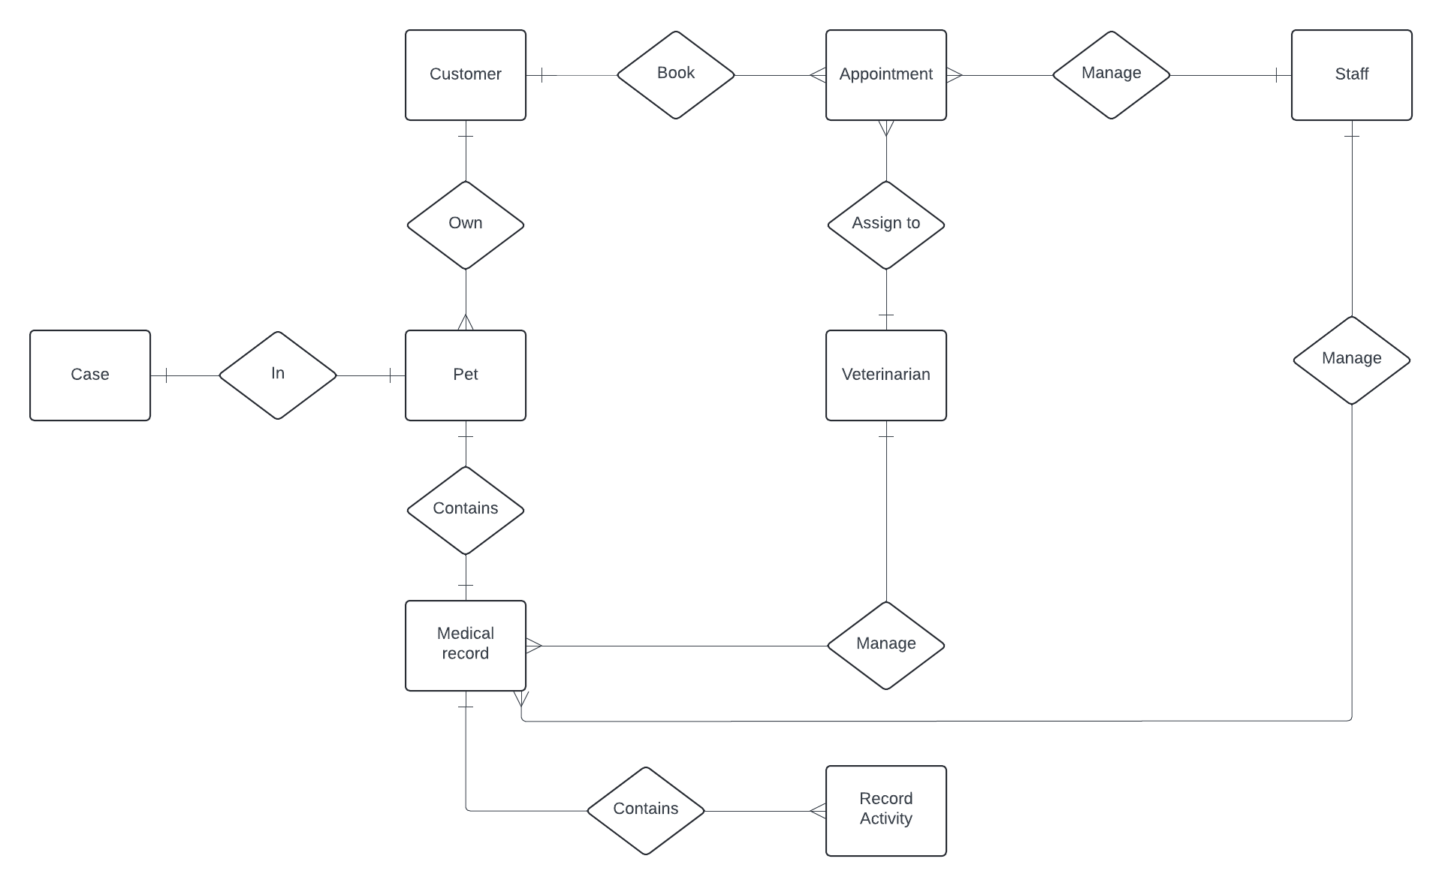

Logical
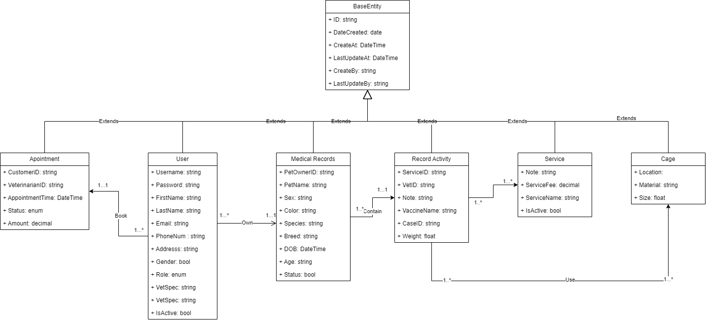

4. Non-Functional Requirements

4.1 External Interfaces :
Pet healthcare systems must interact seamlessly with external entities. These interfaces facilitate communication, data exchange, and integration with other systems. Consider the following aspects:
- User interface:
  - Pet owners: The system must provide an intuitive web interface for pet owners to manage appointments, view medical records, and receive notifications.
  - Veterinarians: Veterinarians need an efficient interface to access patient information, update treatment plans, and communicate with pet owners.
- Third-party integration:
  - Payment Gateway: Integrate with payment gateways to process transactions related to appointments, medications, and services..
- Communication Protocols:
  - RESTful APIs: For communication between the system and mobile apps, web clients, or other services.
  - SMTP/IMAP: Email communication for appointment reminders, notifications, and reports.

4.2 Quality Attributes

4.2.1 Usability:
- The system should be intuitive and easy to navigate for pet owners, veterinarians, and other users.
- Consider factors like clear user interfaces, consistent terminology, and straightforward workflows.

4.2.2 Reliability:
- The system must function correctly and consistently under normal and abnormal conditions.
- It should handle errors gracefully and recover from failures without data loss.
- Ensure high availability to minimise downtime.

4.2.3 Performance:
- Define response time requirements:
  - Response Time: Specify the maximum time the system should take to react to user requests.
  - Throughput: Determine the quantity of transactions or processes the system should handle within a specific timeframe.
  - Scalability: Address how well the system can accommodate a growing workload or user base.

4.2.4 Design Constraints:
- Identify any architectural or technological limitations.

- For example, if you’re using specific frameworks (e.g., ASP.NET Core), consider their constraints.

4.2.1 Security:
- Protect the system and its data from unauthorised access.

- Implement authentication, authorization, and encryption mechanisms.

- Detect and respond to security breaches promptly.

5. Requirement Appendix

5.1 Business Rules
ID | Rule definition
BR-01 | The system must validate all the guests’ sign-up information before creating the guest accounts.
BR-02 | All information entered must comply with the constraints given by the system.
BR-03 | Users are only allowed to choose an appointment time based on the doctor's work shift suggested by the system.
BR-04 | The system must ensure that user has the rights to use authenticated features
BR-05 | The system must ensure that the healing progress data is up-to-date and accurate.
BR-06 | The system must ensure that the feedback data is validated and recorded accurately.
BR-07 | Feedback should be linked to the specific appointment with the veterinarian.
BR-08 | The system must ensure that the appointment data is validated and recorded accurately.
BR-09 | Appointment slots must be checked for availability before confirming the booking.
BR-10 | The system must ensure that the user's session is properly terminated.
BR-11 | The system should securely clear any session-related data.
BR-12 | Ensure data to be private and secured.
BR-13 | Any change on a pet medical record must be notified to the customer.
BR-14 | Data reports can not be deleted, if they somehow got modified, all previous versions are still kept.
BR-15 | The system must ensure that a room with existing bookings cannot be deleted.
BR-16 | Deletions must be confirmed by the staff member to prevent accidental removal.
BR-17 | The system must log all deletion activities for audit purposes.
BR-18 | Room deletion should adhere to the data retention policies defined by the organisation.
BR-19 | The system must ensure that a vet cannot be assigned to more than one room at the same time.
BR-20 | The system must log all assignment activities for audit purposes.
BR-21 | Room and vet assignments should adhere to the scheduling and availability policies defined by the organisation.
BR-22 | The system should be displayed in a user-friendly format
BR-23 | The system must log all actions related to viewing appointments for audit purposes.
BR-24 | Staff must validate the customer's identity before scheduling an appointment.
BR-25 | The system must ensure no double-booking of appointment slots.
BR-26 | All appointments must be confirmed with the customer before finalising.
BR-27 | The data must be retrieved in accordance with the data access and privacy policies defined by the organisation.
BR-28 | Appointment details should be accessible for modification or cancellation by the staff up to 24 hours before the appointment time.
BR-29 | Staff must follow data privacy regulations when handling customer information.
BR-30 | The system must ensure that only valid appointments can be cancelled.
BR-31 | Cancellations must be confirmed by the staff member to prevent accidental cancellations.
BR-32 | The system must log all cancellation activities for audit purposes.
BR-33 | Appointment cancellations should adhere to the organisation’s cancellation policies and procedures.
BR-34 | Only authorised staff members can assign or reassign veterinarians to rooms.
BR-35 | The system must prevent double-booking of both vets and rooms.
BR-36 | Assignments must be confirmed with both the veterinarian and the room scheduler.
BR-37 | Any changes to assignments must be logged and communicated to the affected parties immediately.
BR-38 | The system must comply with all applicable regulations regarding staff scheduling and room management.
BR-39 | Only authenticated veterinarians can view their appointment schedules.
BR-40 | The system must ensure that the appointment data is accurate and up-to-date.
BR-41 | Appointment details must comply with data privacy regulations.
BR-42 | The system must provide an option for veterinarians to print or export their schedule.
BR-43 | Any changes to the schedule (e.g., cancellations, rescheduling) must be promptly reflected in the system.
BR-44 | Only authenticated veterinarians can add or edit medical records.
BR-45 | All medical records must comply with data privacy and security regulations.
BR-46 | The system must ensure that required fields are completed before allowing the record to be saved.
BR-47 | Changes to the medical record must be logged with a timestamp and the user’s ID.
BR-48 | The system should allow veterinarians to update or append additional information to the medical record if needed
BR-49 | Specific data formats may be required for certain service information fields (e.g., date format, phone number format).
BR-50 | Certain service information fields may be mandatory and cannot be left blank. (e.g., service description, pricing, availability)
BR-51 | Staff permissions may restrict which service information fields they can edit.
BR-52 | A service cannot be deleted if it has any active bookings associated with it.
BR-53 | The system should ensure that deleting a service does not cause any data inconsistencies or corrupt other system data.
BR-54 | The price must be entered in a specific format (e.g., currency symbol, decimal places).
BR-55 | Impact on Existing Subscriptions/Bookings: Define how price changes will affect existing subscriptions or bookings. Options include:  - No impact: Existing subscriptions/bookings continue at the original price they were booked under.  - Prorated adjustment: The price change is prorated for existing subscriptions to reflect the remaining duration. (This may require additional business logic)  - Customer notification: The system may require notifying customers about upcoming price changes for their existing subscriptions/bookings.

5.2 Application Messages List
# | Message code | Message Type | Context | Content
01 | MSG01 | Toast Message | Added record successfully | Tạo mới * thành công
02 | MSG02 | Toast Message | Updated record successfully | Cập nhật * thành công
03 | MSG03 | Toast Message | Deleted record successfully | Xóa * thành công
04 | MSG04 | Toast Message | Authentication failed | Tài khoản hoặc mật khẩu không đúng
05 | MSG05 | Toast Message | Request is not valid | * không thành công
06 | MSG06 | Delete Confirm Message | Click delete a record | Bạn có chắc muốn xóa * này?
07 | MSG07 | Error message, text colour red, under input box | Input-required fields are not valid | * không đúng
08 | MSG08 | Error message, text colour red, under input box | Input-required fields are empty | * không được bỏ trống
09 | MSG09 | Error message,  response | Interval Server Error, Request is not  valid and still send to server | * lỗi hệ thống

III. Software Design Description

1. System Design

1.1 System Architecture
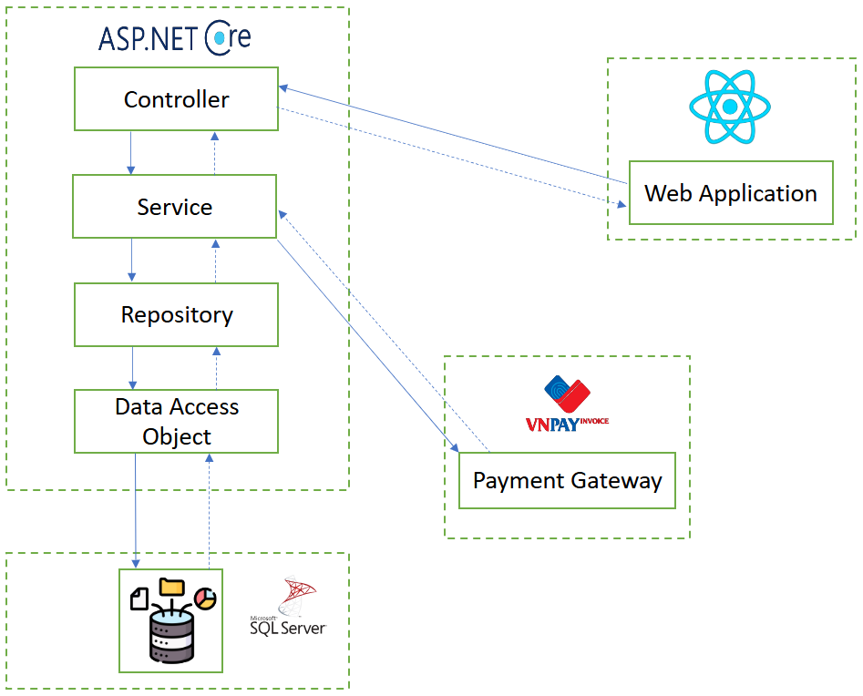

2. Database Design
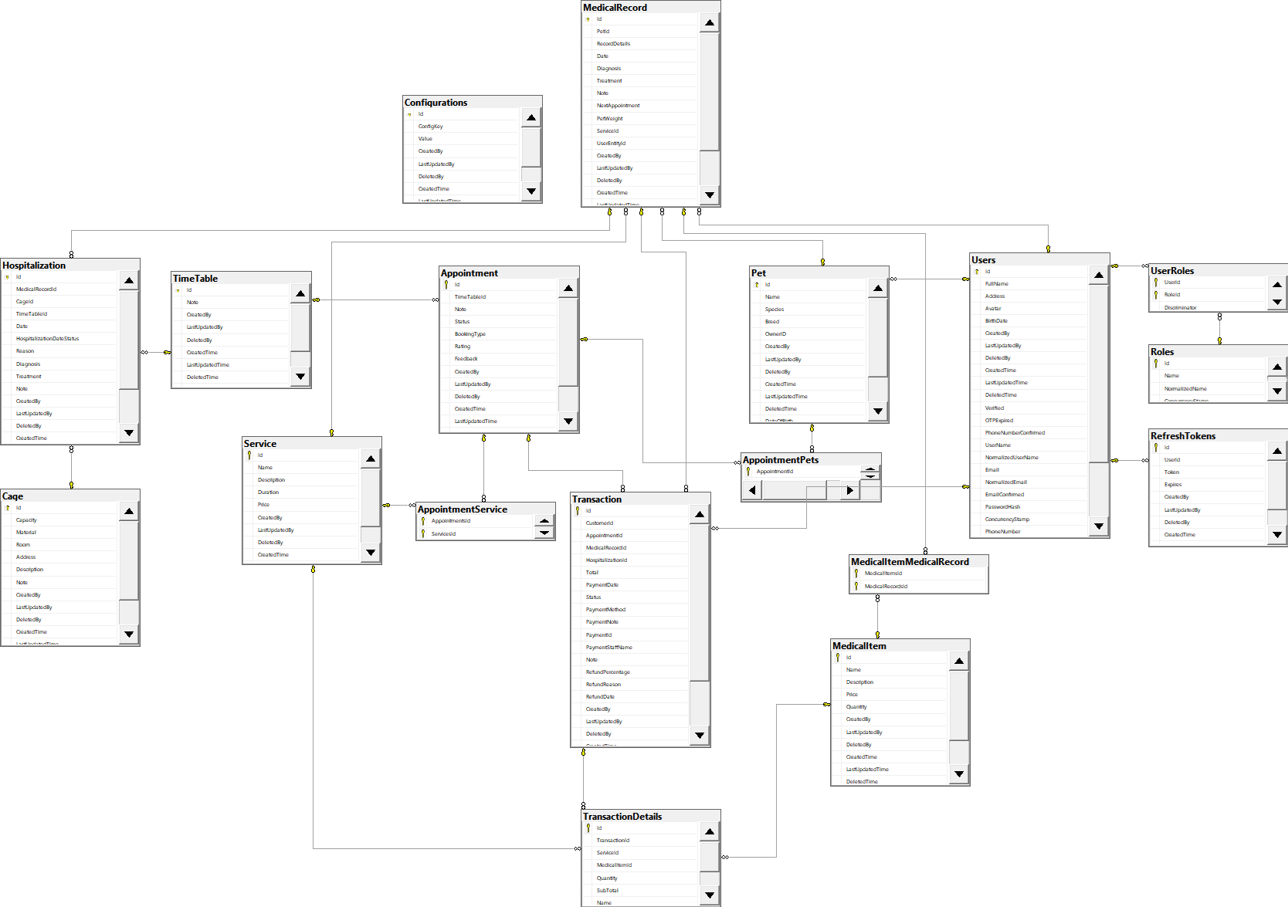
Table description
No | Table | Description
1 | Appointment | Table storing appointment details
2 | AppointmentPets | Table linking appointments to pets
3 | AppointmentService | Table linking appointments to services
4 | Cage | Table storing cage details
5 | Configurations | Table storing configuration settings
6 | Hospitalization | Table storing hospitalization records
7 | MedicalItem | Table storing medical items
8 | MedicalItemMedicalRecord | Table linking medical items to records
9 | MedicalRecord | Table storing medical records
10 | Pet | Table storing pet details
11 | RefreshTokens | Table storing refresh tokens
13 | Roles | Table storing roles
14 | Service | Table storing services
15 | TimeTable | Table storing timetable details
16 | Transaction | Table storing transactions
17 | TransactionDetails | Table storing transaction details
18 | UserRoles | Table linking users to roles
19 | Users | Table storing user details

Attribute Data Dictionary
Entity Name | Attributes | Description | Domain | Null
Appointment | Id {PK} | Unique identifier | int | No
Appointment | TimeTableId | Foreign key, Identifier for timetable | int | No
Appointment | Note | Appointment note | nvarchar(max) | Yes
Appointment | Status | Status of the appointment | int | No
Appointment | BookingType | Type of booking | int | No
Appointment | Rating | Appointment rating | smallint | Yes
Appointment | Feedback | Feedback from appointment | nvarchar(max) | Yes
Appointment | CreatedBy | User who created the record | int | Yes
Appointment | LastUpdatedBy | User who last updated the record | int | Yes
Appointment | DeletedBy | User who deleted the record | int | Yes
Appointment | CreatedTime | Record creation time | datetimeoffset(7) | No
Appointment | LastUpdatedTime | Last update time | datetimeoffset(7) | No
Appointment | DeletedTime | Record deletion time | datetimeoffset(7) | Yes
Appointment | VetId | Foreign key, Veterinarian ID | int | No
Appointment | AppointmentDate | Date of appointment | date | No
AppointmentPets | Id {PK} | Unique identifier | int | No
AppointmentPets | AppointmentId | Foreign key, Identifier for appointment | int | No
AppointmentPets | PetId | Foreign key, Identifier for pet | int | No
AppointmentService | Id {PK} | Unique identifier | int | No
AppointmentService | AppointmentsId | Foreign key, Identifier for appointment | int | No
AppointmentService | ServicesId | Foreign key, Identifier for service | int | No
Cage | Id {PK} | Unique identifier | int | No
Cage | Capacity | Capacity of the cage | int | No
Cage | Material | Material of the cage | nvarchar(max) | Yes
Cage | Room | Room identifier | int | Yes
Cage | Address | Address of the cage | nvarchar(max) | Yes
Cage | Description | Description of the cage | nvarchar(max) | Yes
Cage | Note | Note about the cage | nvarchar(max) | Yes
Cage | CreatedBy | User who created the record | int | Yes
Cage | LastUpdatedBy | User who last updated the record | int | Yes
Cage | DeletedBy | User who deleted the record | int | Yes
Cage | CreatedTime | Record creation time | datetimeoffset(7) | No
Cage | LastUpdatedTime | Last update time | datetimeoffset(7) | No
Cage | DeletedTime | Record deletion time | datetimeoffset(7) | Yes
Cage | IsAvailable | Availability status | bit | No
Configurations | Id {PK} | Unique identifier | int | No
Configurations | ConfigKey | Configuration key | nvarchar(max) | No
Configurations | Value | Configuration value | nvarchar(max) | No
Configurations | CreatedBy | User who created the record | int | Yes
Configurations | LastUpdatedBy | User who last updated the record | int | Yes
Configurations | DeletedBy | User who deleted the record | int | Yes
Configurations | CreatedTime | Record creation time | datetimeoffset(7) | No
Configurations | LastUpdatedTime | Last update time | datetimeoffset(7) | No
Configurations | DeletedTime | Record deletion time | datetimeoffset(7) | Yes
Hospitalisation | Id {PK} | Unique identifier | int | No
Hospitalisation | MedicalRecordId | Foreign key, Identifier for medical record | int | No
Hospitalisation | CageId | Foreign key, Identifier for cage | int | No
Hospitalisation | TimeTableId | Foreign key, Identifier for timetable | int | Yes
Hospitalisation | Date | Hospitalisation date | date | No
Hospitalisation | HospitalizationDateStatus | Status of the hospitalisation date | int | No
Hospitalisation | Reason | Reason for hospitalisation | nvarchar(max) | Yes
Hospitalisation | Diagnosis | Diagnosis information | nvarchar(max) | Yes
Hospitalisation | Treatment | Treatment information | nvarchar(max) | Yes
Hospitalisation | Note | Note about the hospitalisation | nvarchar(max) | Yes
Hospitalisation | CreatedBy | User who created the record | int | Yes
Hospitalisation | LastUpdatedBy | User who last updated the record | int | Yes
Hospitalisation | DeletedBy | User who deleted the record | int | Yes
Hospitalisation | CreatedTime | Record creation time | datetimeoffset(7) | No
Hospitalisation | LastUpdatedTime | Last update time | datetimeoffset(7) | No
Hospitalisation | DeletedTime | Record deletion time | datetimeoffset(7) | Yes
Hospitalisation | VetId | Foreign key, Veterinarian ID | int | No
MedicalItem | Id {PK} | Unique identifier | int | No
MedicalItem | Name | Name of the medical item | nvarchar(max) | No
MedicalItem | Description | Description of the medical item | nvarchar(max) | Yes
MedicalItem | Price | Price of the medical item | decimal(18, 0) | No
MedicalItem | Quantity | Quantity of the medical item | int | No
MedicalItem | CreatedBy | User who created the record | int | Yes
MedicalItem | LastUpdatedBy | User who last updated the record | int | Yes
MedicalItem | DeletedBy | User who deleted the record | int | Yes
MedicalItem | CreatedTime | Record creation time | datetimeoffset(7) | No
MedicalItem | LastUpdatedTime | Last update time | datetimeoffset(7) | No
MedicalItem | DeletedTime | Record deletion time | datetimeoffset(7) | Yes
MedicalItem | MedicalItemType | Type of the medical item | int | No
MedicalItem | Note | Note about the medical item | nvarchar(max) | Yes
MedicalItemMedicalRecord | Id {PK} | Unique identifier | int | No
MedicalItemMedicalRecord | MedicalItemsId | Foreign key, Identifier for medical item | int | No
MedicalItemMedicalRecord | MedicalRecordsId | Foreign key, Identifier for medical record | int | No
MedicalRecord | Id {PK} | Unique identifier | int | No
MedicalRecord | PetId | Foreign key, Identifier for pet | int | No
MedicalRecord | RecordDetails | Details of the record | nvarchar(max) | Yes
MedicalRecord | Date | Date of the record | datetimeoffset(7) | No
MedicalRecord | Diagnosis | Diagnosis information | nvarchar(max) | Yes
MedicalRecord | Treatment | Treatment information | nvarchar(max) | Yes
MedicalRecord | Note | Note about the record | nvarchar(max) | Yes
MedicalRecord | NextAppointment | Next appointment date and time | datetimeoffset(7) | Yes
MedicalRecord | PetWeight | Weight of the pet | decimal(5, 2) | No
MedicalRecord | ServiceId | Foreign key, Identifier for service | int | Yes
MedicalRecord | UserEntityId | Foreign key, Identifier for user entity | int | Yes
MedicalRecord | CreatedBy | User who created the record | int | Yes
MedicalRecord | LastUpdatedBy | User who last updated the record | int | Yes
MedicalRecord | DeletedBy | User who deleted the record | int | Yes
MedicalRecord | CreatedTime | Record creation time | datetimeoffset(7) | No
MedicalRecord | LastUpdatedTime | Last update time | datetimeoffset(7) | No
MedicalRecord | DeletedTime | Record deletion time | datetimeoffset(7) | Yes
MedicalRecord | AdmissionDate | Admission date of the pet | datetimeoffset(7) | Yes
MedicalRecord | DischargeDate | Discharge date of the pet | datetimeoffset(7) | Yes
Pet | Id {PK} | Unique identifier | int | No
Pet | Name | Name of the pet | nvarchar(max) | Yes
Pet | Species | Species of the pet | nvarchar(max) | Yes
Pet | Breed | Breed of the pet | nvarchar(max) | Yes
Pet | OwnerID | Foreign key, Identifier for customer | int | No
Pet | CreatedBy | User who created the record | int | Yes
Pet | LastUpdatedBy | User who last updated the record | int | Yes
Pet | DeletedBy | User who deleted the record | int | Yes
Pet | CreatedTime | Record creation time | datetimeoffset(7) | No
Pet | LastUpdatedTime | Last update time | datetimeoffset(7) | No
Pet | DeletedTime | Record deletion time | datetimeoffset(7) | Yes
Pet | DateOfBirth | Date of birth of the pet | datetimeoffset(7) | No
Pet | IsNeutered | Neutering status | bit | No
Pet | Gender | Gender of the pet | nvarchar(max) | Yes
RefreshTokens | Id {PK} | Unique identifier | int | No
RefreshTokens | UserId | Foreign key, Identifier for user | int | No
RefreshTokens | Token | Refresh token | nvarchar(max) | No
RefreshTokens | Expires | Expiry date and time | datetimeoffset(7) | No
RefreshTokens | CreatedBy | User who created the record | int | Yes
RefreshTokens | LastUpdatedBy | User who last updated the record | int | Yes
RefreshTokens | DeletedBy | User who deleted the record | int | Yes
RefreshTokens | CreatedTime | Record creation time | datetimeoffset(7) | No
RefreshTokens | LastUpdatedTime | Last update time | datetimeoffset(7) | No
RefreshTokens | DeletedTime | Record deletion time | datetimeoffset(7) | Yes
Roles | Id {PK} | Unique identifier | int | No
Roles | Name | Name of the role | nvarchar(256) | Yes
Roles | NormalizedName | Normalised name of the role | nvarchar(256) | Yes
Roles | ConcurrencyStamp | Concurrency stamp | nvarchar(max) | Yes
Service | Id {PK} | Unique identifier | int | No
Service | Name | Name of the service | nvarchar(max) | No
Service | Description | Description of the service | nvarchar(max) | Yes
Service | Duration | Duration of the service | int | No
Service | Price | Price of the service | decimal(18, 0) | No
Service | CreatedBy | User who created the record | int | Yes
Service | LastUpdatedBy | User who last updated the record | int | Yes
Service | DeletedBy | User who deleted the record | int | Yes
Service | CreatedTime | Record creation time | datetimeoffset(7) | No
Service | LastUpdatedTime | Last update time | datetimeoffset(7) | No
Service | DeletedTime | Record deletion time | datetimeoffset(7) | Yes
TimeTable | Id {PK} | Unique identifier | int | No
TimeTable | Note | Note about the timetable | nvarchar(max) | Yes
TimeTable | CreatedBy | User who created the record | int | Yes
TimeTable | LastUpdatedBy | User who last updated the record | int | Yes
TimeTable | DeletedBy | User who deleted the record | int | Yes
TimeTable | CreatedTime | Record creation time | datetimeoffset(7) | No
TimeTable | LastUpdatedTime | Last update time | datetimeoffset(7) | No
TimeTable | DeletedTime | Record deletion time | datetimeoffset(7) | Yes
TimeTable | EndTime | End time of the timetable | time(7) | No
TimeTable | StartTime | Start time of the timetable | time(7) | No
Transaction | Id {PK} | Unique identifier | int | No
Transaction | CustomerId | Foreign key, Identifier for customer | int | No
Transaction | AppointmentId | Foreign key, Identifier for appointment | int | Yes
Transaction | MedicalRecordId | Foreign key, Identifier for medical record | int | Yes
Transaction | HospitalizationId | Foreign key, Identifier for hospitalisation | int | Yes
Transaction | Total | Total amount | decimal(18, 0) | No
Transaction | PaymentDate | Payment date and time | datetimeoffset(7) | Yes
Transaction | Status | Status of the transaction | int | No
Transaction | PaymentMethod | Method of payment | int | Yes
Transaction | PaymentNote | Note about the payment | nvarchar(max) | Yes
Transaction | PaymentId | Payment identifier | nvarchar(max) | Yes
Transaction | PaymentStaffName | Name of the payment staff | nvarchar(max) | Yes
Transaction | Note | Note about the transaction | nvarchar(max) | Yes
Transaction | RefundPercentage | Percentage of refund | decimal(5, 2) | Yes
Transaction | RefundReason | Reason for refund | nvarchar(max) | Yes
Transaction | RefundDate | Refund date and time | datetimeoffset(7) | Yes
Transaction | CreatedBy | User who created the record | int | Yes
Transaction | LastUpdatedBy | User who last updated the record | int | Yes
Transaction | DeletedBy | User who deleted the record | int | Yes
Transaction | CreatedTime | Record creation time | datetimeoffset(7) | No
Transaction | LastUpdatedTime | Last update time | datetimeoffset(7) | No
Transaction | DeletedTime | Record deletion time | datetimeoffset(7) | Yes
Transaction | PaymentStaffId | Identifier for payment staff | int | Yes
Transaction | RefundPaymentId | Refund payment identifier | nvarchar(max) | Yes
TransactionDetails | Id {PK} | Unique identifier | int | No
TransactionDetails | TransactionId | Foreign key, Identifier for transaction | int | No
TransactionDetails | ServiceId | Foreign key, Identifier for service | int | Yes
TransactionDetails | MedicalItemId | Foreign key, Identifier for medical item | int | Yes
TransactionDetails | Quantity | Quantity of the item/service | int | No
TransactionDetails | SubTotal | Subtotal amount | decimal(18, 0) | No
TransactionDetails | Name | Name of the item/service | nvarchar(max) | Yes
TransactionDetails | Price | Price of the item/service | decimal(18, 0) | No
UserRoles | Id {PK} | Unique identifier | int | No
UserRoles | UserId | Foreign key, Identifier for user | int | No
UserRoles | RoleId | Foreign key, Identifier for role | int | No
UserRoles | Discriminator | Discriminator for user roles | nvarchar(21) | No
Users | Id {PK} | Unique identifier | int | No
Users | FullName | Full name of the user | nvarchar(max) | Yes
Users | Address | Address of the user | nvarchar(max) | Yes
Users | Avatar | Avatar image of the user | nvarchar(max) | Yes
Users | BirthDate | Birthdate of the user | datetimeoffset(7) | Yes
Users | CreatedBy | User who created the record | nvarchar(max) | Yes
Users | LastUpdatedBy | User who last updated the record | nvarchar(max) | Yes
Users | DeletedBy | User who deleted the record | nvarchar(max) | Yes
Users | CreatedTime | Record creation time | datetimeoffset(7) | No
Users | LastUpdatedTime | Last update time | datetimeoffset(7) | No
Users | DeletedTime | Record deletion time | datetimeoffset(7) | Yes
Users | Verified | Verification timestamp | datetimeoffset(7) | Yes
Users | OTPExpired | OTP expiration timestamp | datetimeoffset(7) | Yes
Users | PhoneNumberConfirmed | Confirmation status of phone number | bit | No
Users | UserName | Username of the user | nvarchar(256) | Yes
Users | NormalizedUserName | Normalized username | nvarchar(256) | Yes
Users | Email | Email of the user | nvarchar(256) | Yes
Users | NormalizedEmail | Normalized email | nvarchar(256) | Yes
Users | EmailConfirmed | Confirmation status of email | bit | No
Users | PasswordHash | Hashed password | nvarchar(max) | Yes
Users | ConcurrencyStamp | Concurrency stamp | nvarchar(max) | Yes
Users | PhoneNumber | Phone number of the user | nvarchar(max) | Yes
Users | TwoFactorEnabled | Two-factor authentication enabled status | bit | No
Users | LockoutEnd | Lockout end timestamp | datetimeoffset(7) | Yes
Users | LockoutEnabled | Lockout enabled status | bit | No
Users | AccessFailedCount | Count of failed access attempts | int | No
Users | OTP | OTP for user verification | nvarchar(max) | Yes

3. Detailed Design

3.1 Pet Feature

3.1.1 Activity Diagram

3.1.1.1 View Pet Activity Diagram
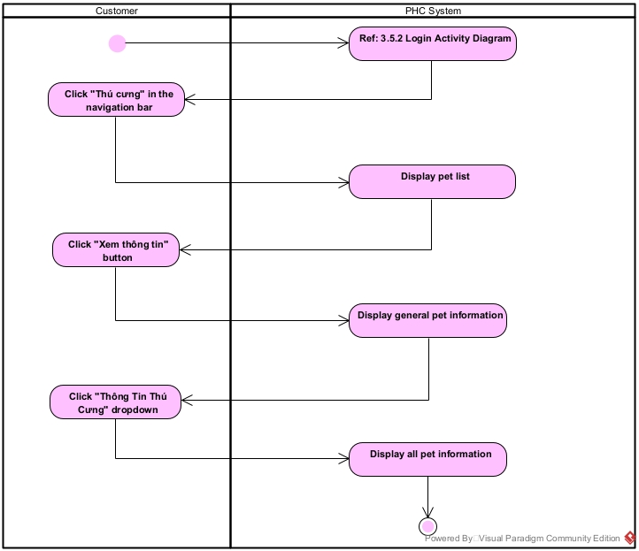

3.1.1.2 Create Pet Activity Diagram
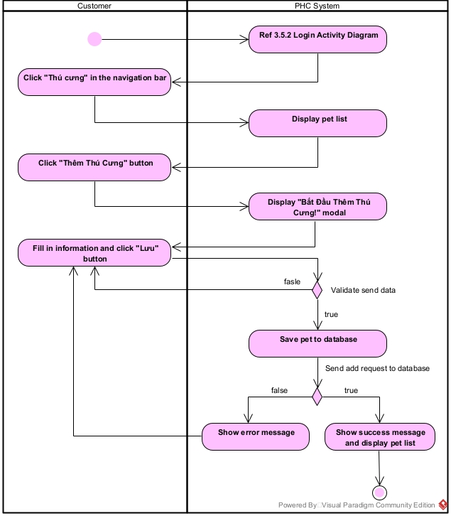

3.1.1.3 Edit Pet Activity Diagram
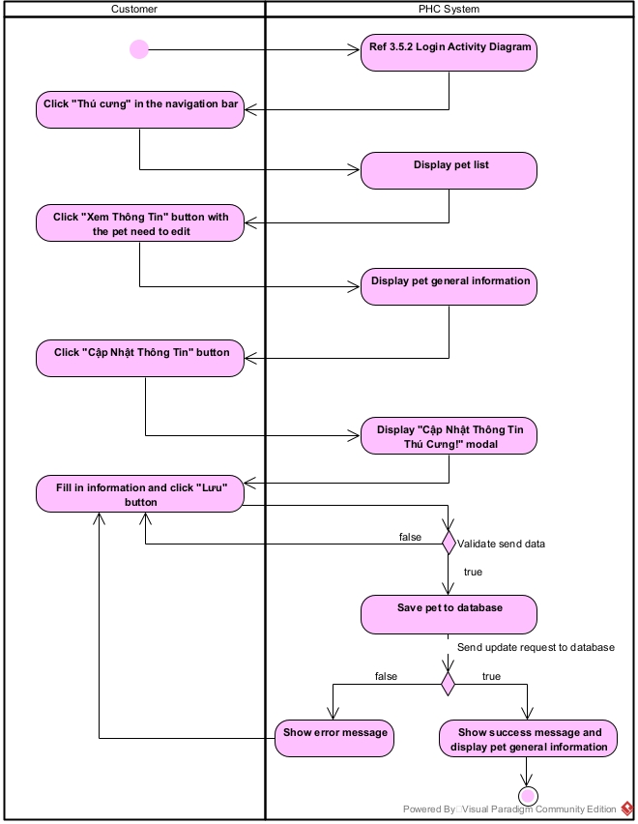

3.1.1.4 Delete Pet Activity Diagram
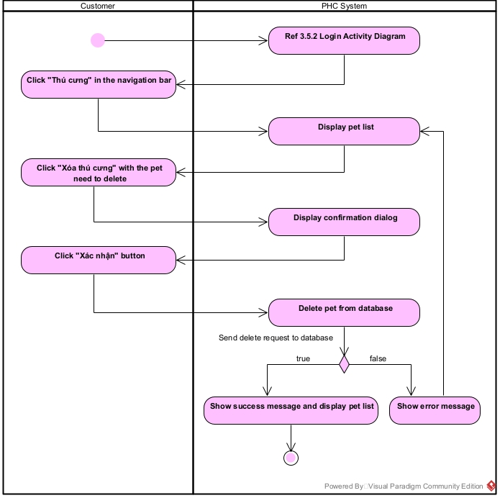

3.1.2 Create Pet Sequence Diagram
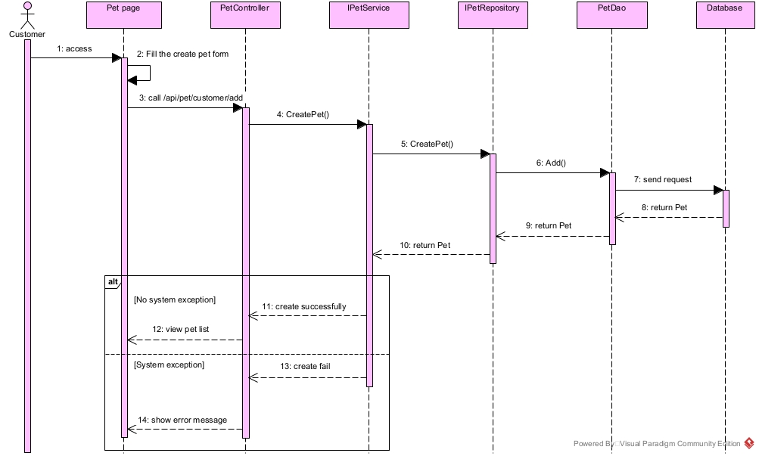

3.2 Booking Feature

3.2.1 Activity Diagram

3.2.1.1 Book Appointment Activity Diagram
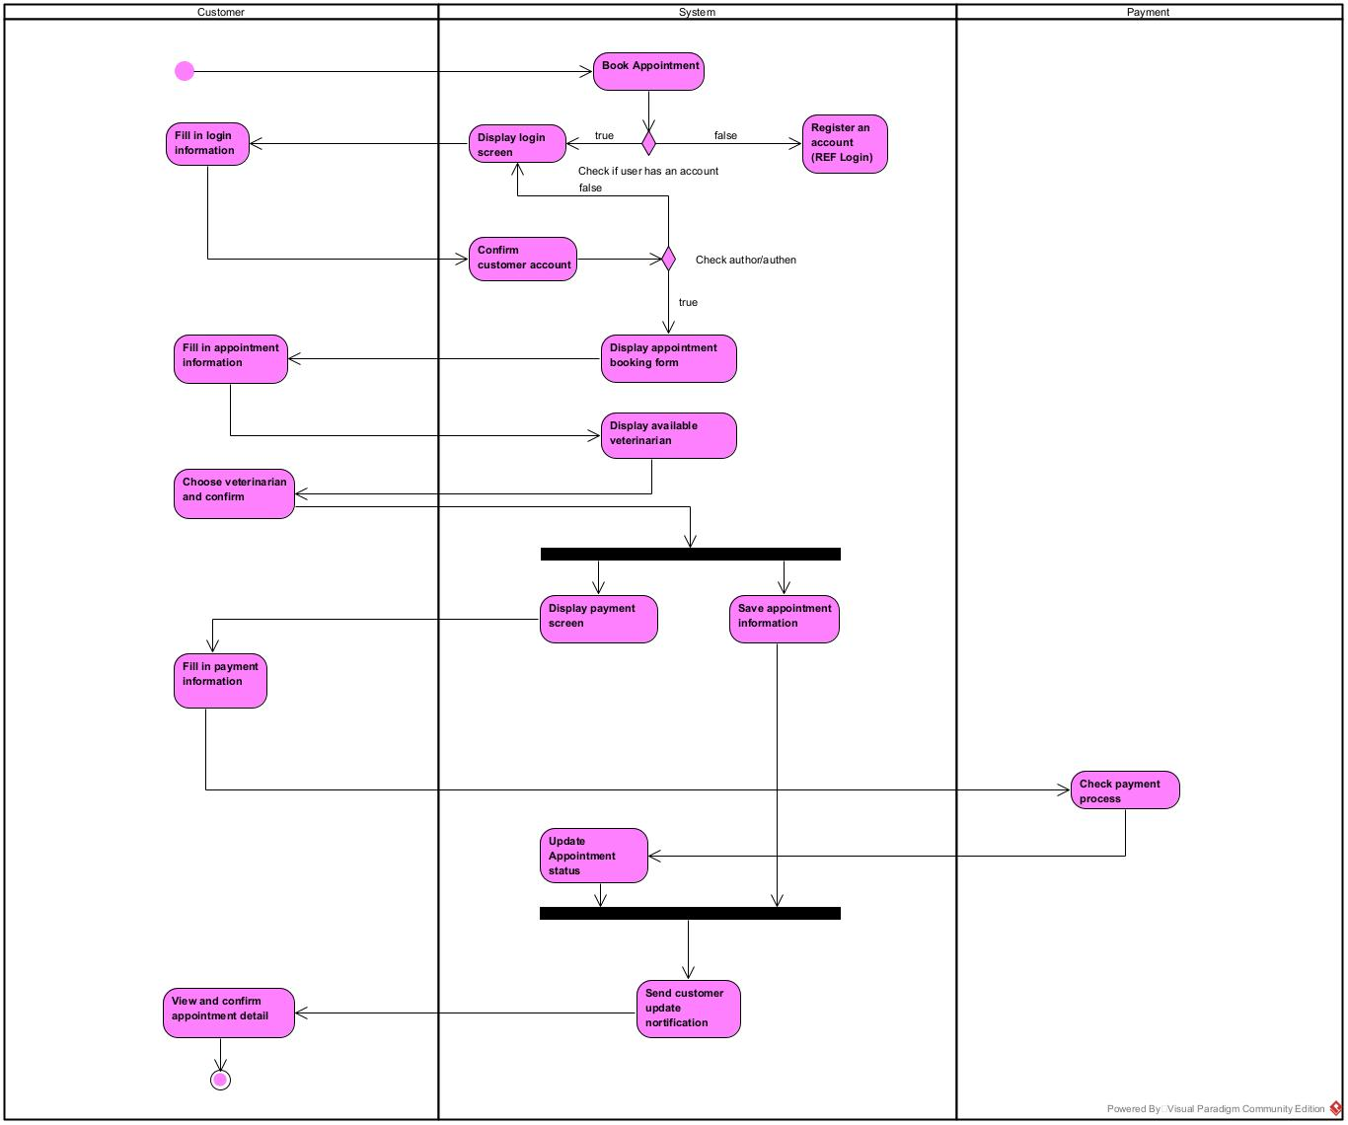

3.2.1.2 Cancel Appointment Activity Diagram
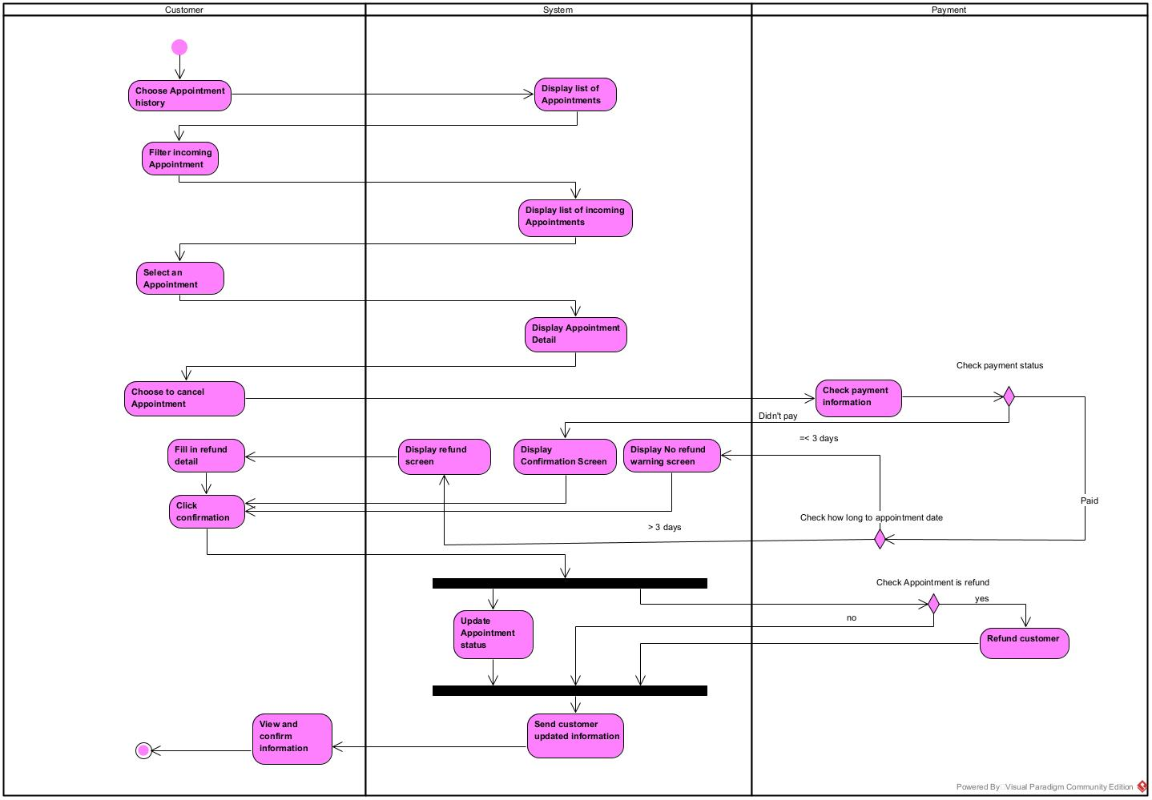

3.2.2 Book Appointment Sequence Diagram
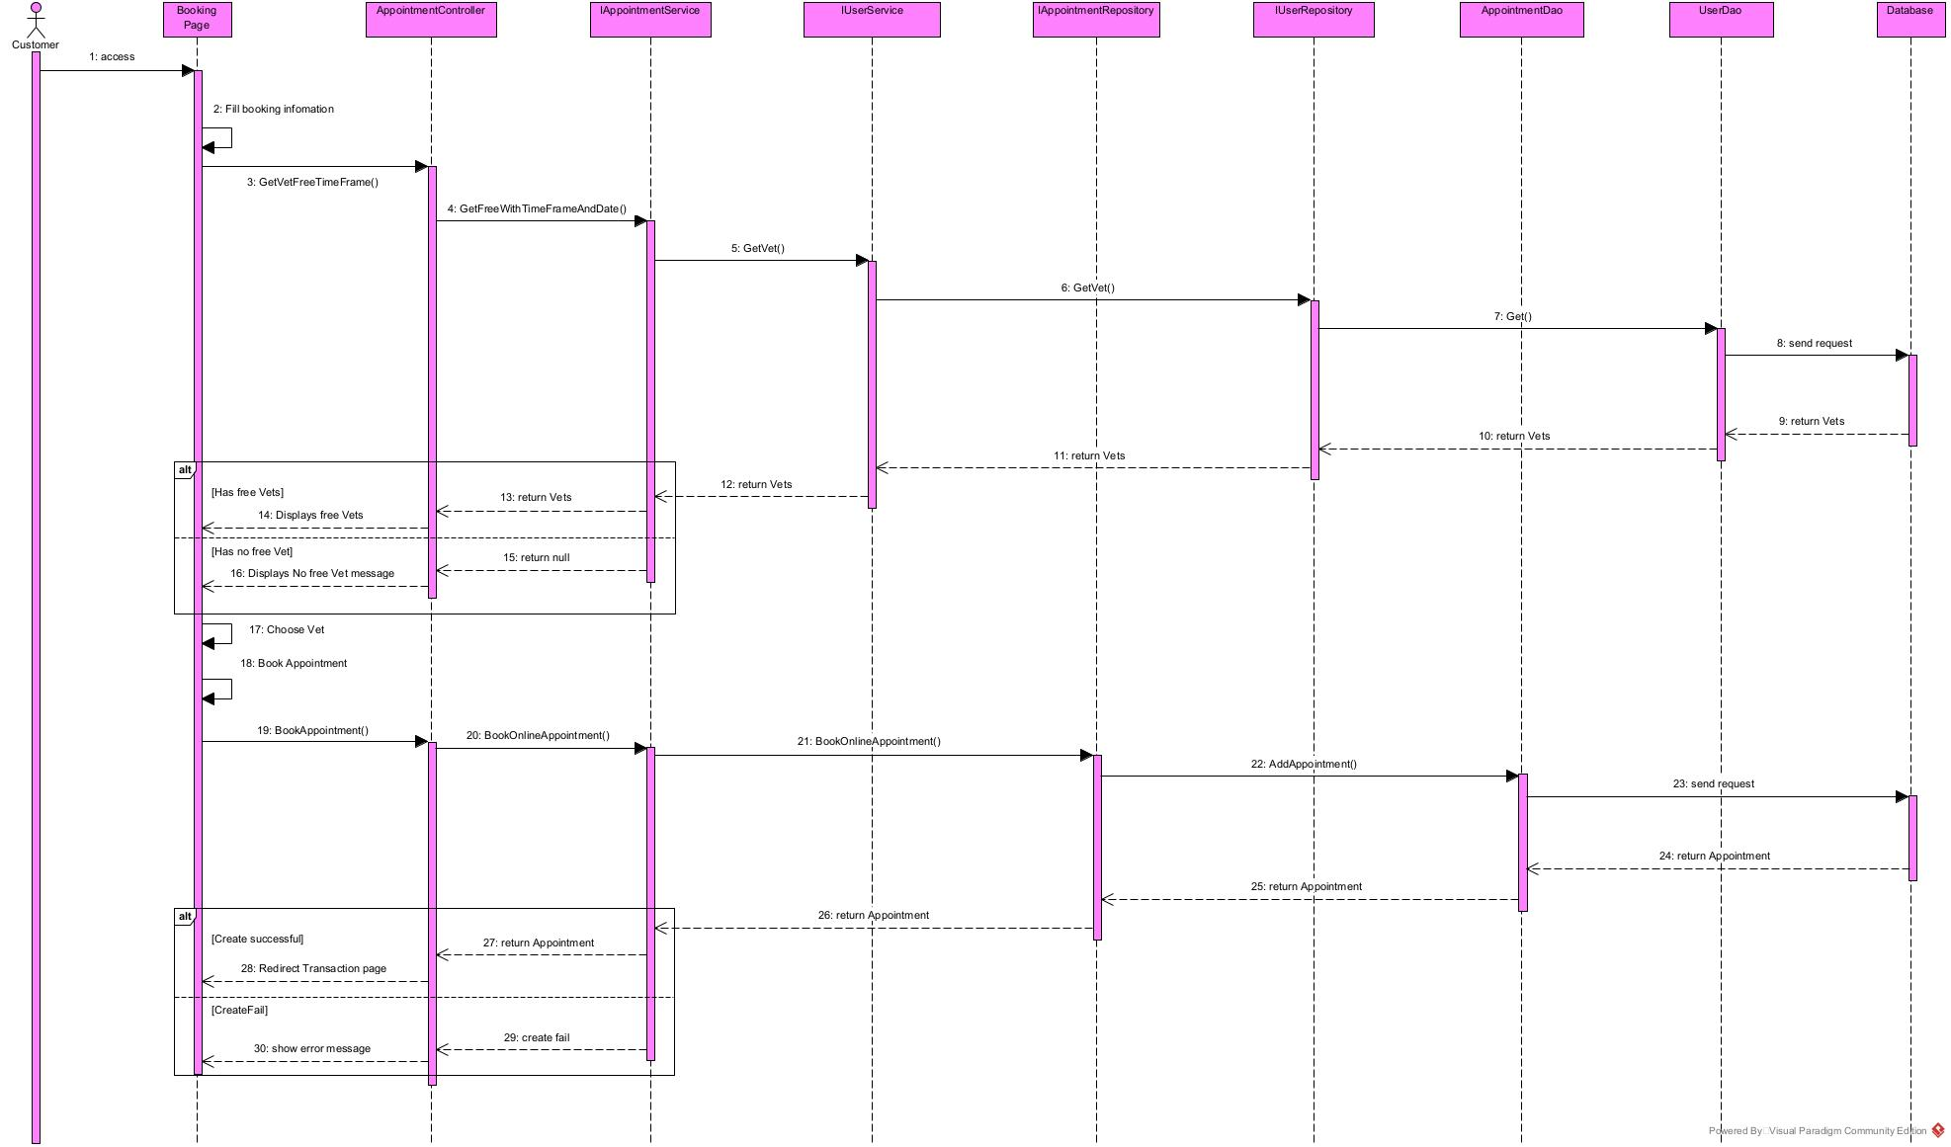

3.2.3 Appointment State Machine Diagram
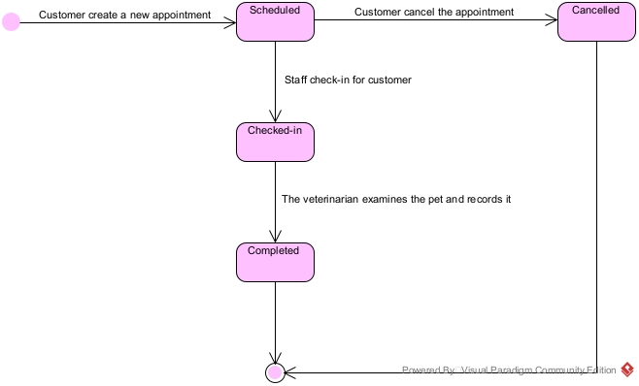

3.3 Medical Record Feature

3.3.1 Activity Diagram

3.3.1.1 Vet write
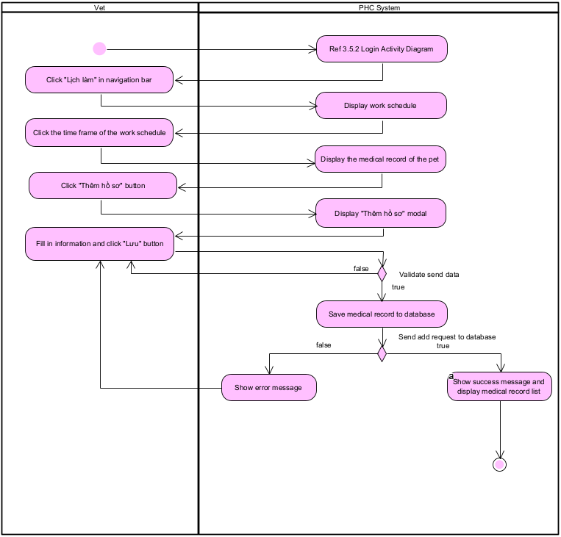

3.3.1.2 Customer View
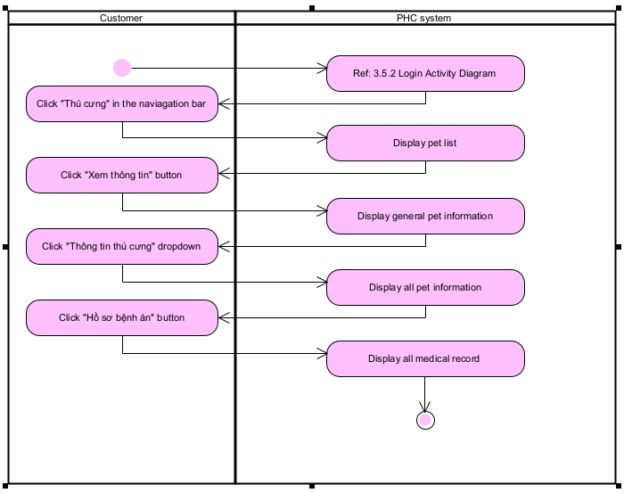

3.3.2 Customer View Medical Record Sequence Diagram
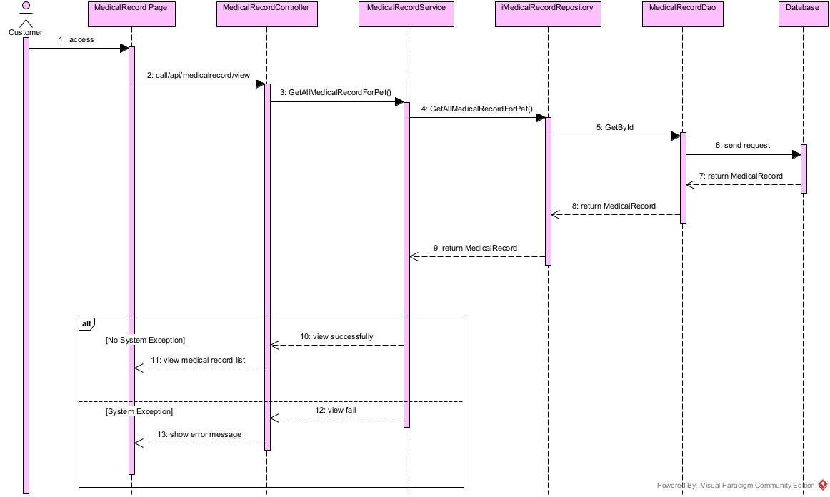

3.4 Hospitalization Feature

3.4.1 Activity Diagram

3.4.1.1 Staff create hospitalization
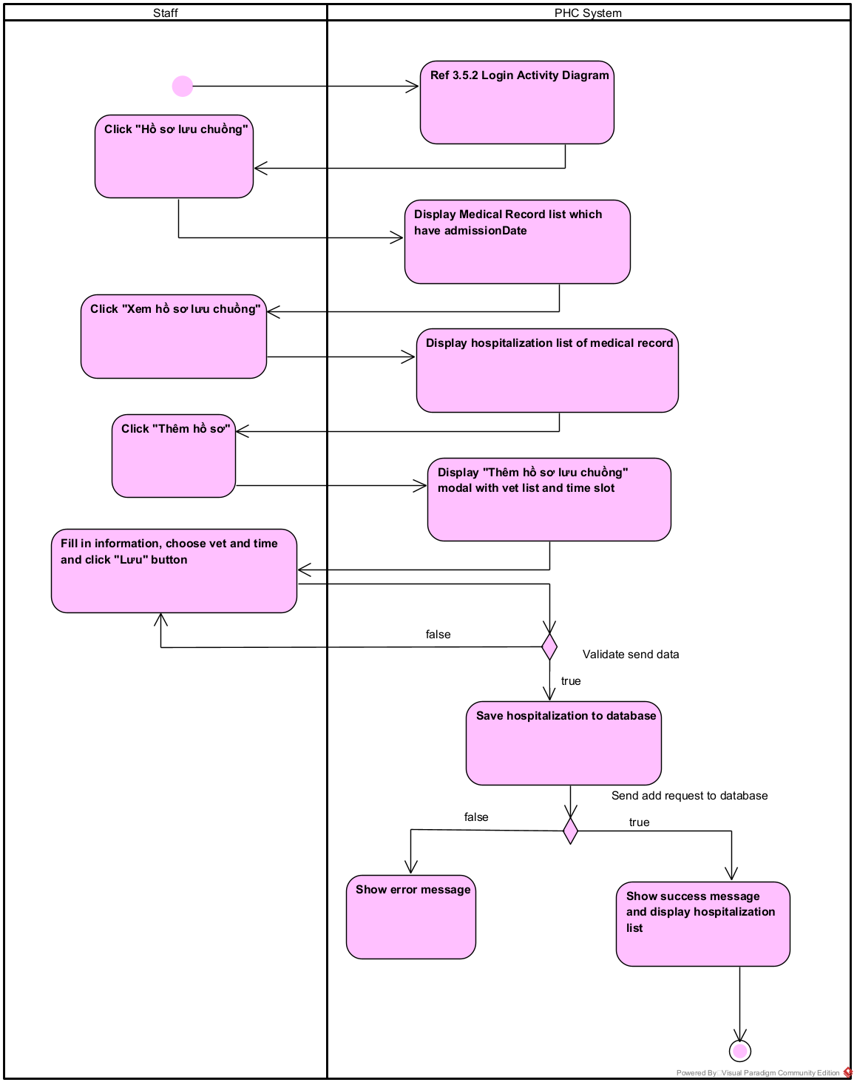

3.4.1.1 Customer view hospitalization
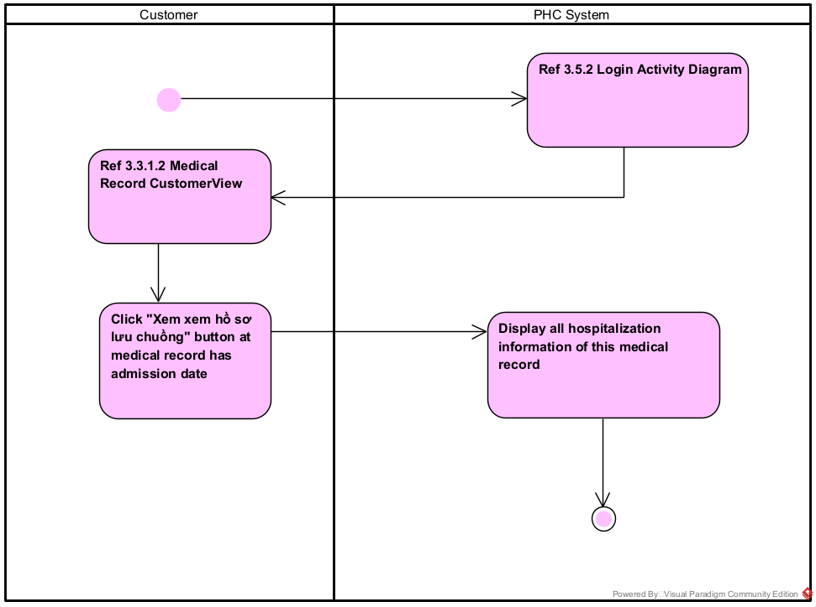

3.4.2 Customer View Hospitalization Sequence Diagram
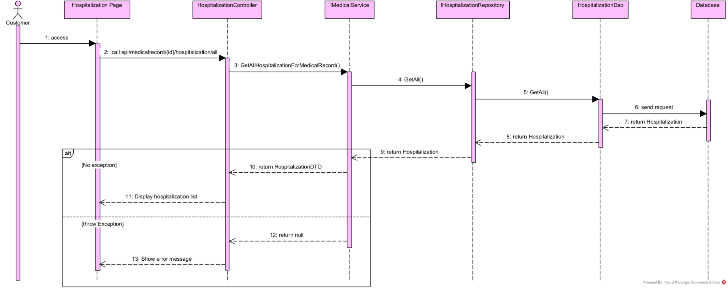

3.5 Other Activity Diagrams

3.5.1 Register Activity Diagram:
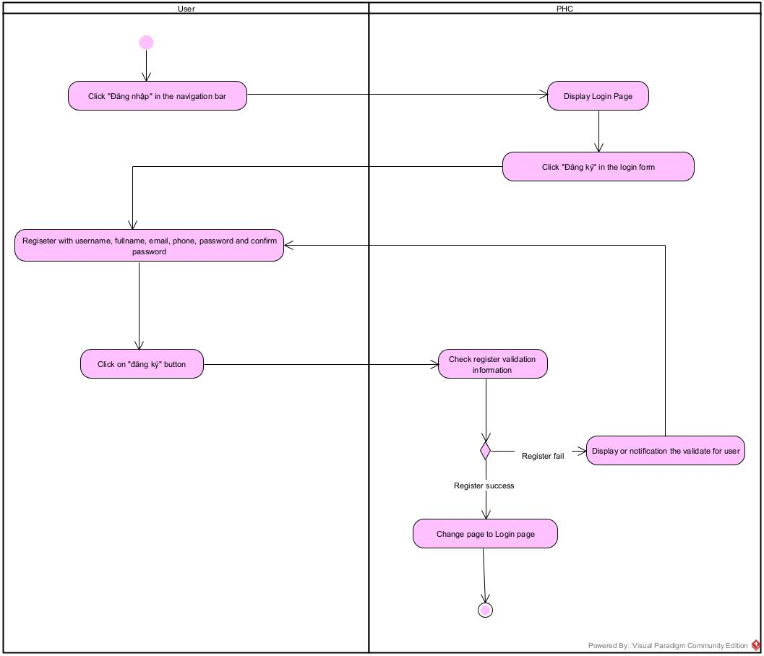

3.5.2 Login Activity Diagram:
